10.36 inch Smart Monitor 4G Android Touch Screen
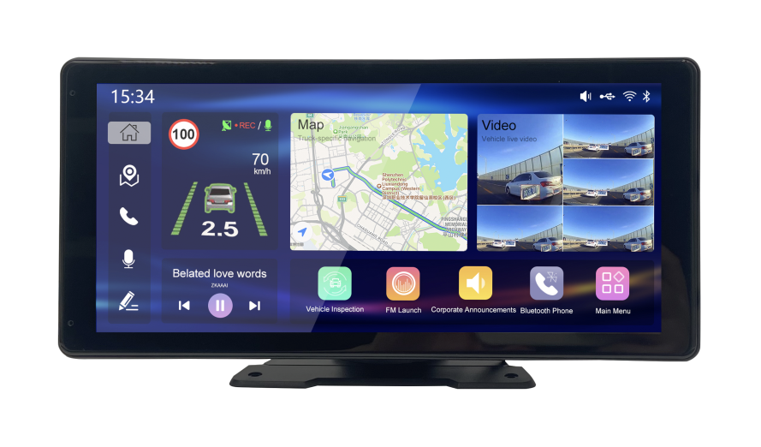
Model JK12A (with 4G)
- Introduction
This 10.36 inch vehicle smart monitor is an Android touch screen that can work with the vehicle MDVR, and support the maximum 5 channels of AHD cameras display on screen. It can realize map navigation, vehicle status information display, camera video display, driver driving record, Bluetooth phone, mobile screen mirroring, multimedia player, FM launch, assistant APPs and other functions.
It’s suitable for different vehicles, such as trucks, vans, etc.
- Order model
JK12A-GFN (with GPS + 4G)
JK12A-GFW (with GPS + 4G+ WI-FI)
- Features
- Android 10.0
- 10.36 inch HD touch screen, resolution 1600*720
- Storage with a TF card slot, up to 512GB
- Support GPS ,4G, WI-FI (optional)
- Support 5-CH 1080P AHD preview on screen
- Support 4-CH 720P AHD video recording files, or 2-CH 1080P AHD video recording files
- Support DSM and ADAS, with voice warning and flashing icon prompts alert of R-watch function on screen
- Fast display of backup camera without the system start-up completely
- Local footage playback
- Support Bluetooth
- Support F.M Radio, to use the vehicle audio system
- Support U-disk for multimedia playback (music, videos, pictures)
- Support 360 panoramic cameras (customized)
- Support navigation and route planning APPs (customized)
- Support other assistant Apps (customized)
- Support to work with MDVR (customized)
- Specification
System
Operation System | Android 10.0
CPU | Quad-core Cortex™-A53
GPU | Mali G31 MP2
CPU frequency | 1.5GHz
RAM Capacity | 2GB
ROM Capacity | 16GB
Storage
Storage Slot | 1 TF Card slot，up to 512G
Display
Size | 10.36 inch
Resolution | 500 cd/m2
Screen ratio | 16:7
Resolution | 1600*720
Screen | Touch Screen
Video
Video input | Support 5-CH 1080P AHD preview on screen;  Support 4-CH 720P AHD video recording files, or 2-CH 1080P AHD video recording files.
Audio input
MIC | Built -in dual MIC
Audio Output
Speaker | Internal speaker 2W8Ω
F.M Radio | Support F.M Radio, to use the vehicle audio system
Network
Network | Support to use the shared network from the MDVR via the RJ45
WIFI | Support
4G | Support
Bluetooth | Support
Ports
RS232 | 2*RS232, one is used to interact with MDVR, and the other is used to connect the peripherals.
USB | 1*USB (Type-C)
IO-IN | 1*IO-IN, Support vehicle reversing signal collection
GPS | Support
Power
Voltage Input | DC 9-36V
Dimension/ weight
Dimensions | 271 x 133.7 x 33.5 mm
Weight | 0.8 KG
Environment
Operating temperature | -25℃~+75℃
Storage temperature | -40℃~+80℃
Operating humidity | 15% ~ 95%
- Dimension
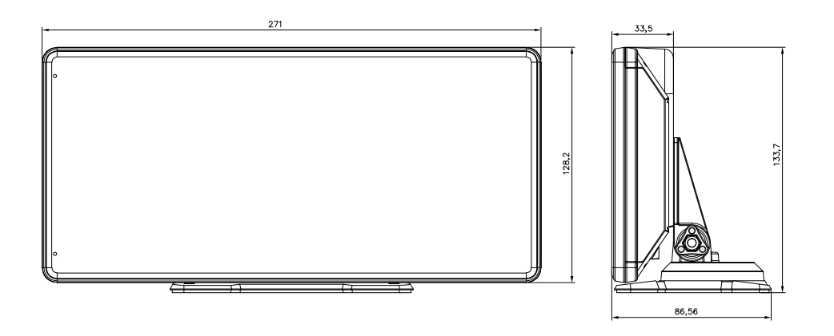

- Installation renderings
