Add features on IVMS: format and retrieve log remotely
- Close the IVMS. Then open the file config.ini (via Notepad) under C:\Users\Administrator\AppData\Roaming\cmsv6
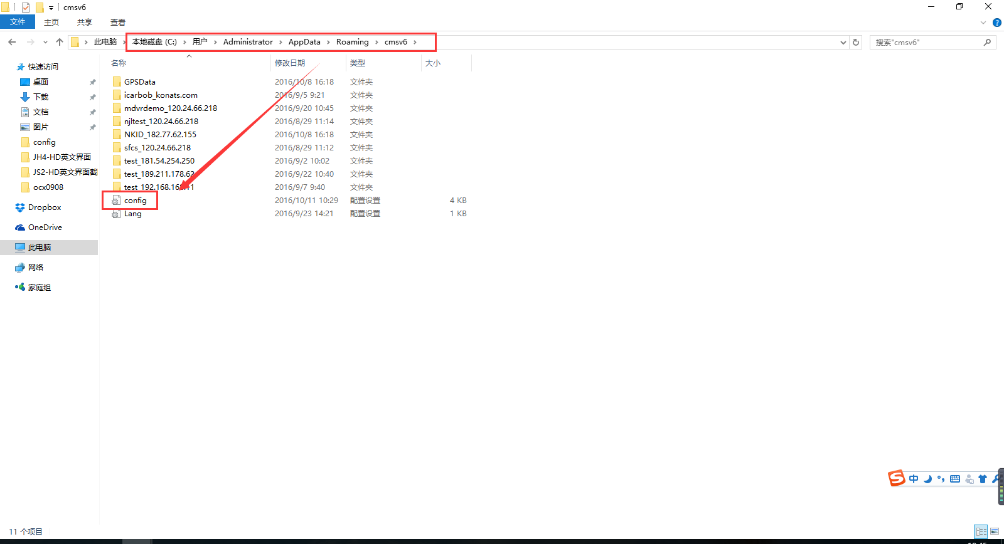

- Add the following into the config file
[DEV_LOG]
OPEN_LOG=1
[FUNCTION]
FORMATHDD=1
Save it after finished.
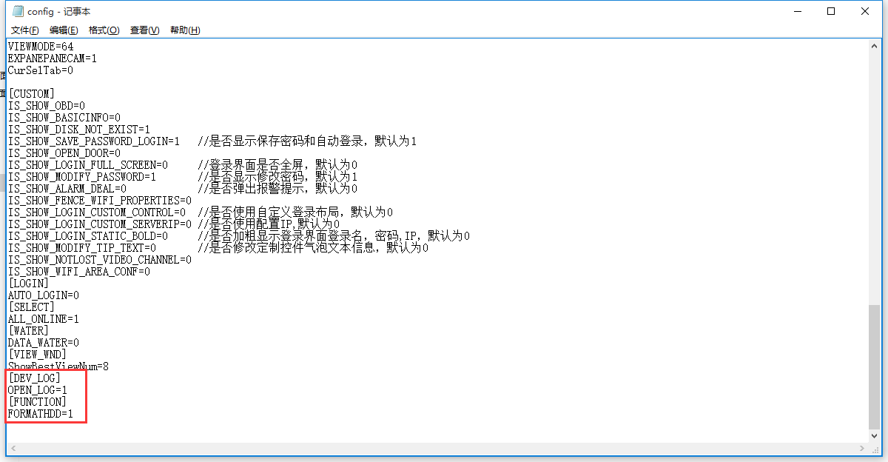

- Restart IVMS. Right click the online device, you will see the remote format feature.
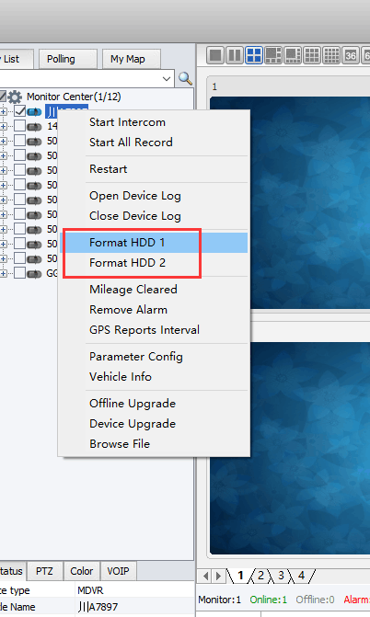

- On the video search page, you will see the feature of remote downloading the log.
