Offline Upgrade Instruction
- Login IVMS Client, select one device from the device list, right click, and click “Offline Upgrade”.
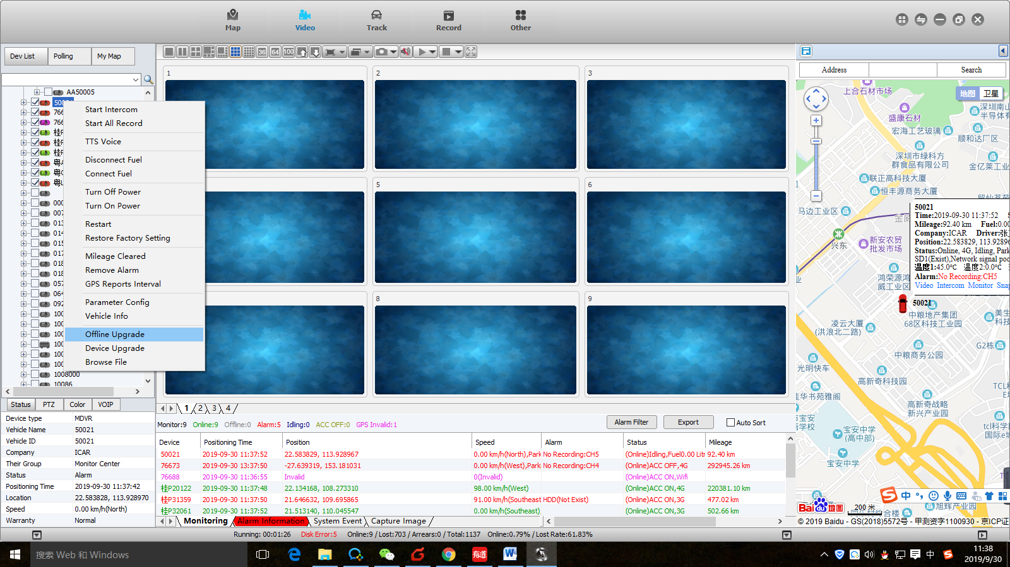

- Click “Get file”, then click ”Upload file”, and select the file which you want to upgrade, input the version name, choose MCU or Firmware, and click “OK”, the file will be uploaded.
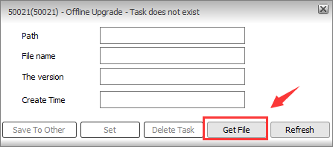
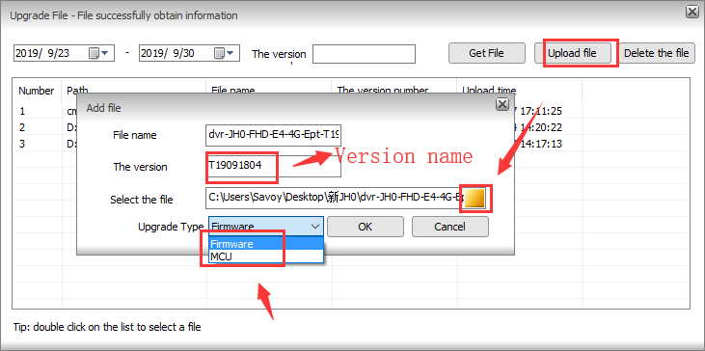

- When the file is uploading, it will show like this, when it finished, it will show on the table, double click the file, then you can click “set” to set offline upgrade task, it will show Offline upgrade task setting successfully.
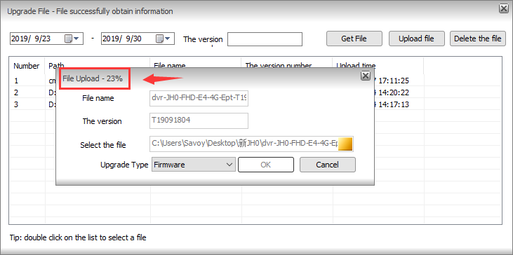
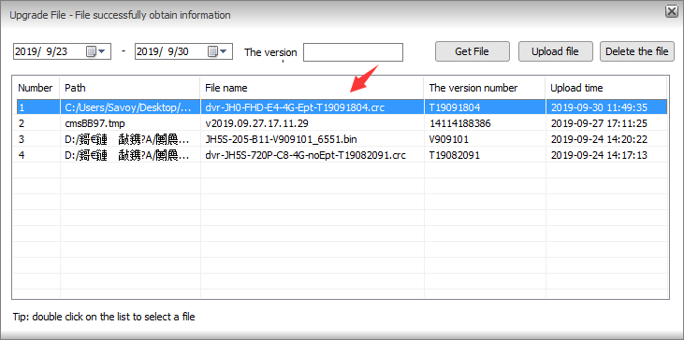
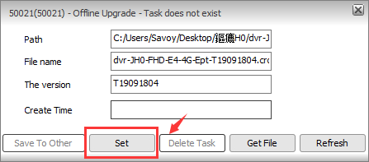
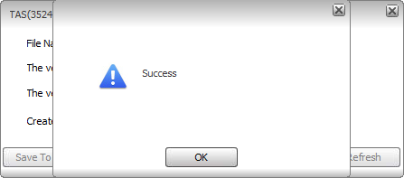
- When the device getting online again, the new firmware will be upgraded automatically according to the task.
- You can also click “Delete task” to delete the offline upgrade task, and you can click “Save to other” to set the same task for other devices.
