How to clear the NT kernel to occupy web port 80

1 Run 'netstat -ano' to find that port 80 is occupied by the process with pid=4
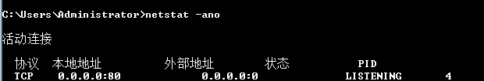

- Open the task manager and find that the process with pid=4 is actually the system process. The corresponding process description is NT kernel & system.

- Need to use the registry, start - "regedit", open
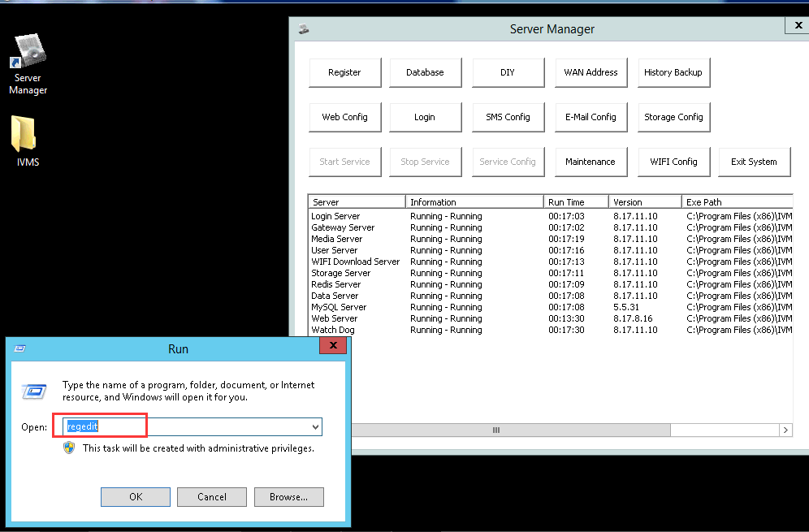

4 Find the HKEY_LOCAL_MACHINE directory
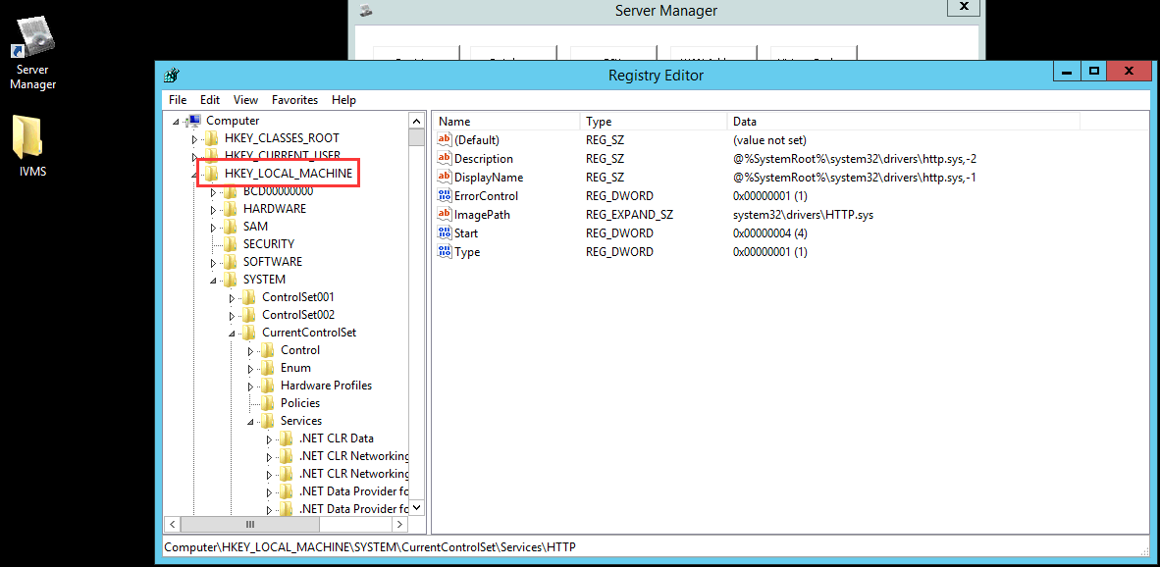
5. Found System
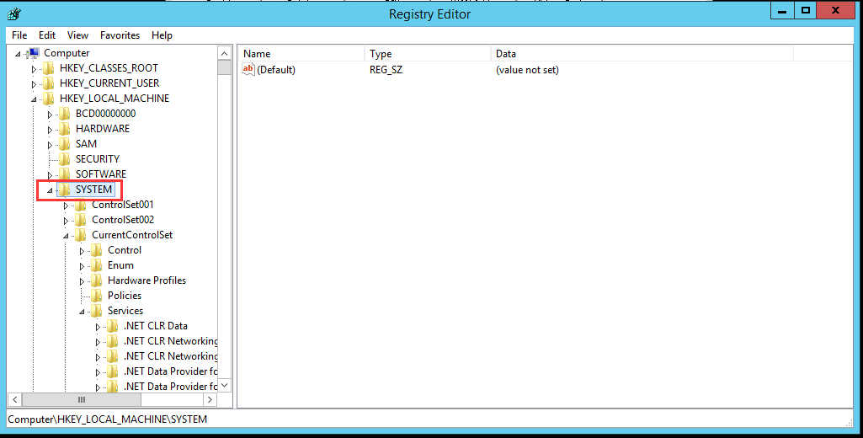
6. Find CurrentControlSet-Services
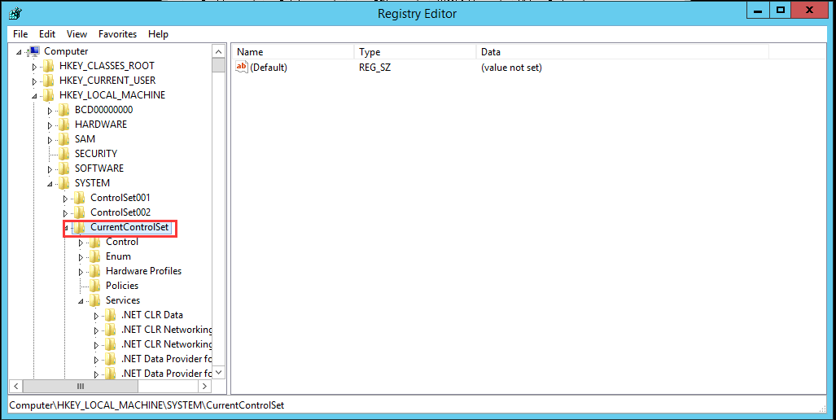
- Find http-start
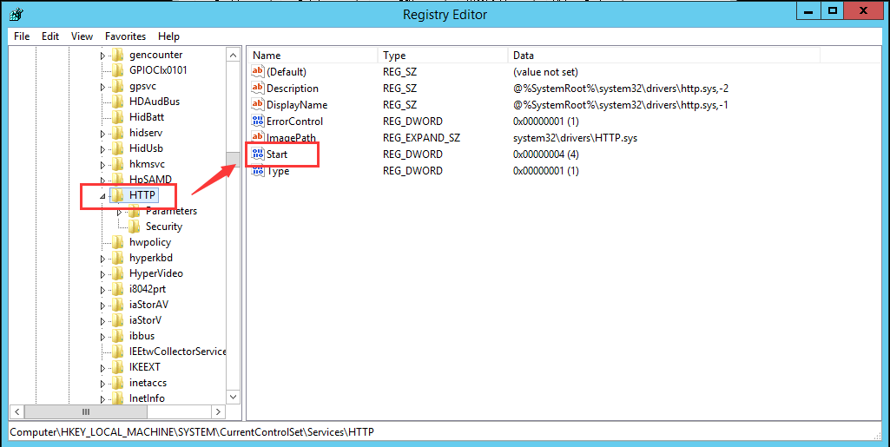
8. Open, change 3 to 4, confirm, after save it, please restart the server PC and it will work.
