IVMSServer Mysql enable remote access

1 Configure my.ini file
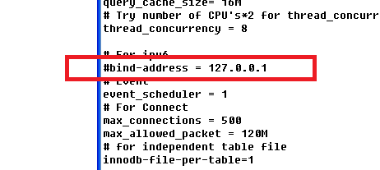

Modify bind-address = 127.0.0.1 to #bind-address=127.0.0.1

2.Modify user file to enable users remote access
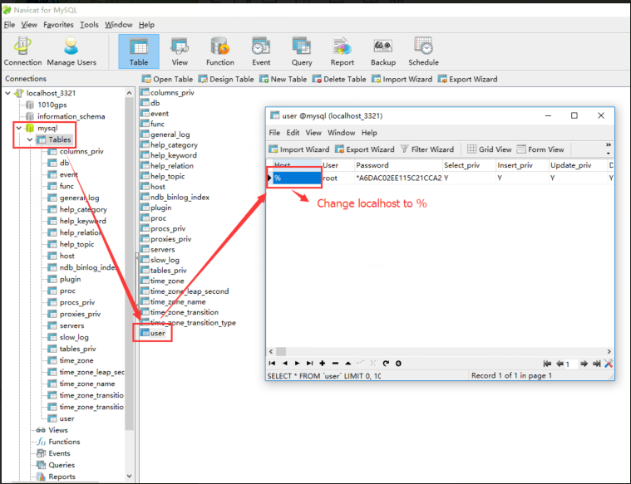

3.Restart mysql server

4.Windows firewall（or close firewall）
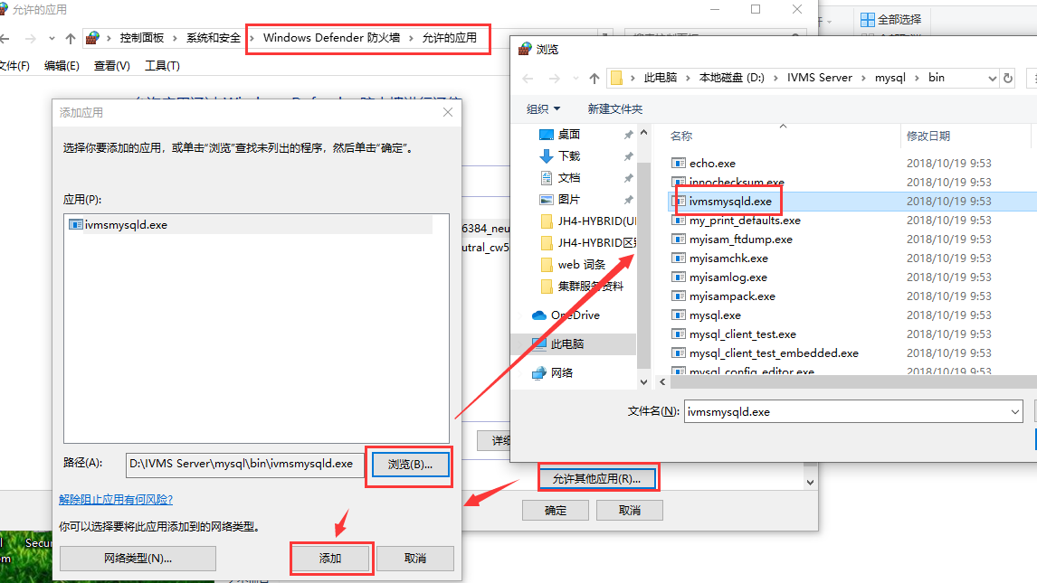

5．Modify server’s database.ini settings.
