How to disassemble the button cell of the MDVR
- Use the Allen wrench to disassemble the front and rear panel’s four screws.
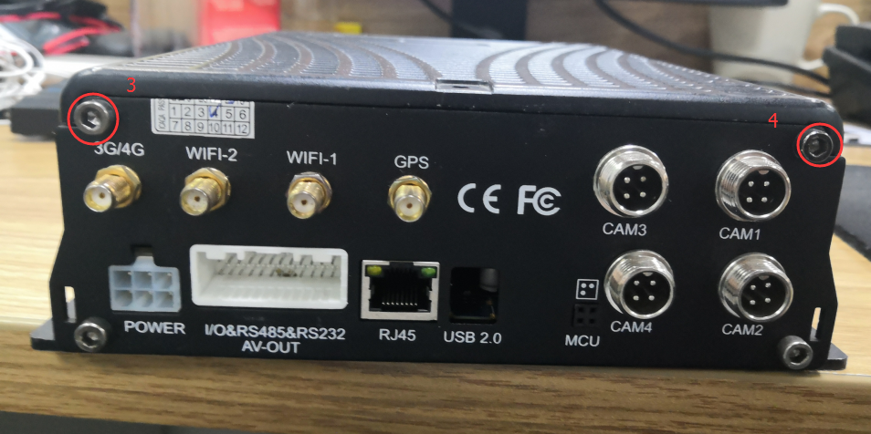
- Open the top cover and push it forward from the back panel.
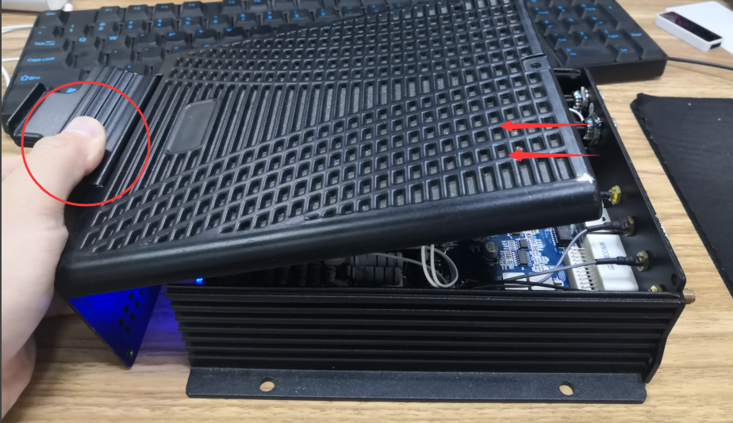
- You don't need to take the entire cover off to see the button battery, so it is recommended not to move the cable inside, just use the button battery alone.
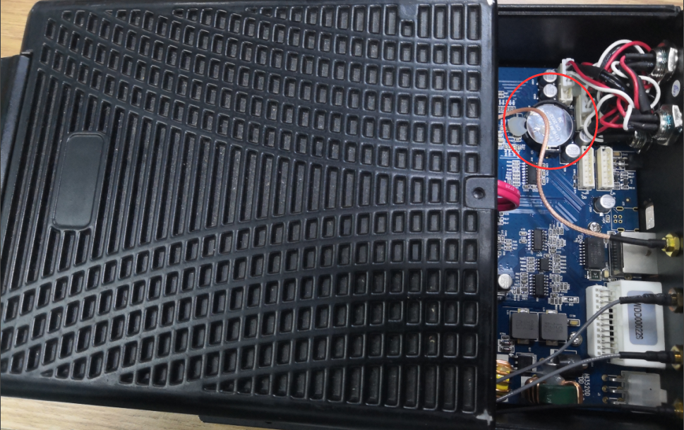
- In the process of taking the button cell, please pay attention to the other circuits on the board, do not touch and force to change them. There is a lock around the button cell, as shown. With the hex wrench pressing the lock, the button battery will automatically move up. But before that, you can clean up the gelatin on the button cell.
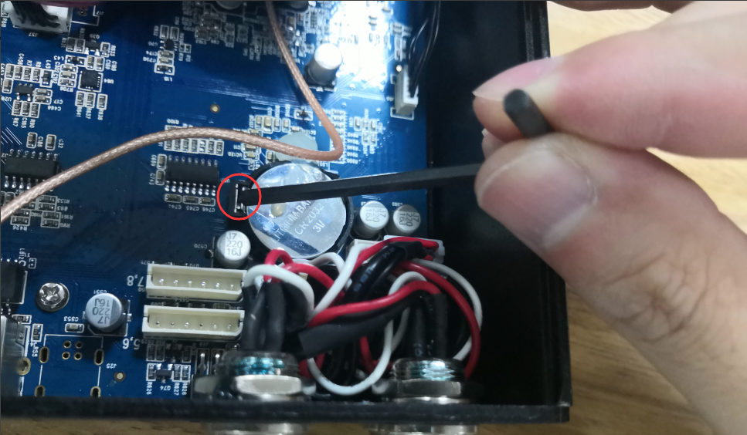
- When assemble it, the same step, press the button cell, and make sure that the lock is locked, and then put a little gelatin on the edge to ensure it is stable.
