How to solve duplicate device ID on IVMS old server
When users plan to add new device ID in IVMS old server, the system will show below error:
IDNO. has been used!
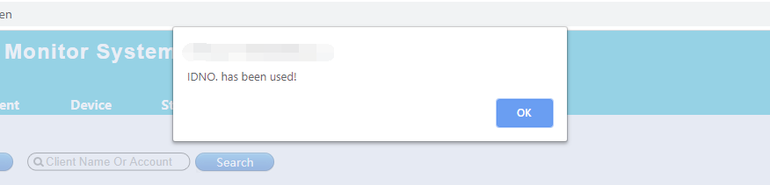
Then please go to your IVMS old server part and follow below steps:
- First, download the Navicat for mysql software from this link and install it.
https://www.dropbox.com/sh/a44t2tv3o78jok4/AAA6vG9AeX1yeDamAwcfMiSka?dl=0

- Use Navicat for mysql login the database, you can follow this picture.
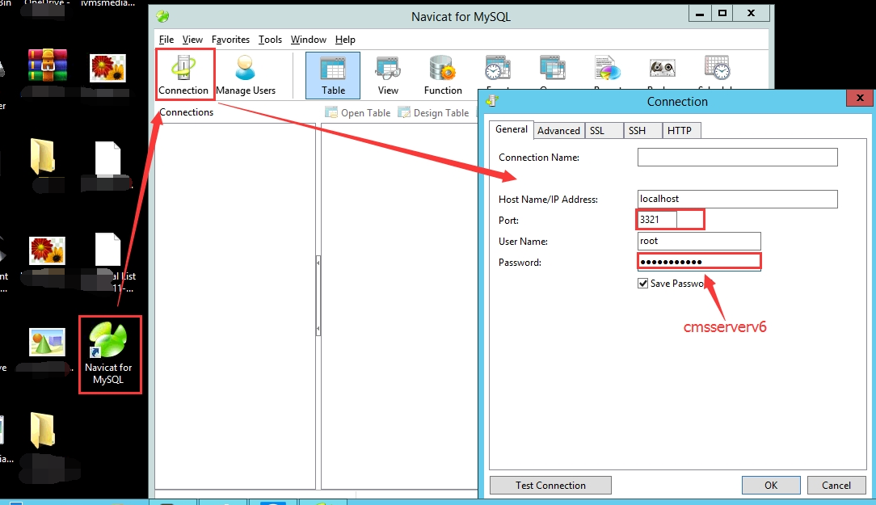

- Then check the account, use_info, dev_info, etc. You can use this command check it:
- select dev_info.AccountID, dev_info.IDNO from dev_info WHERE dev_info.AccountID noT IN (SELECT ID FROM account)
- select account.ID, account.Account from account WHERE account.Type=1 AND account.id NOT IN(SELECT AccountID FROM dev_info)
- select account.ID, account.Account from account WHERE Type=1 AND account.ID noT IN (SELECT AccountID FROM dev_info)
- select * from dev_info WHERE dev_info.IDNO not in (select Account from account)
- select * from user_info u where u.AccountID not in (select ID from account)

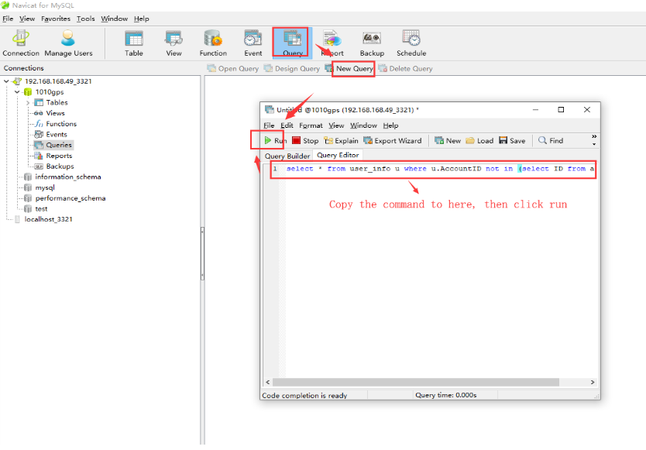

- If it get some error, you need to change it in the table. like this one , you need to check account and dev_info table, if it is only in a table, you can delete it, then save it.
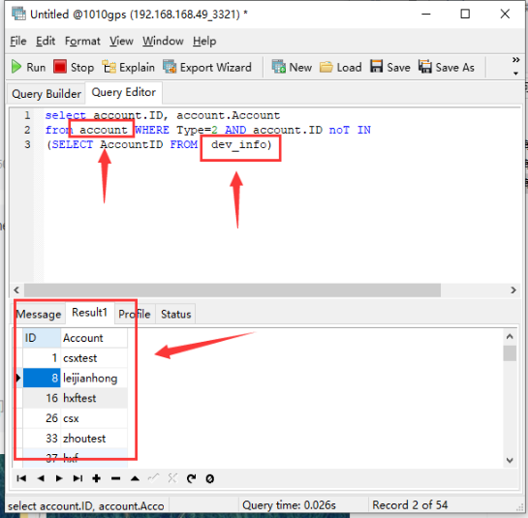
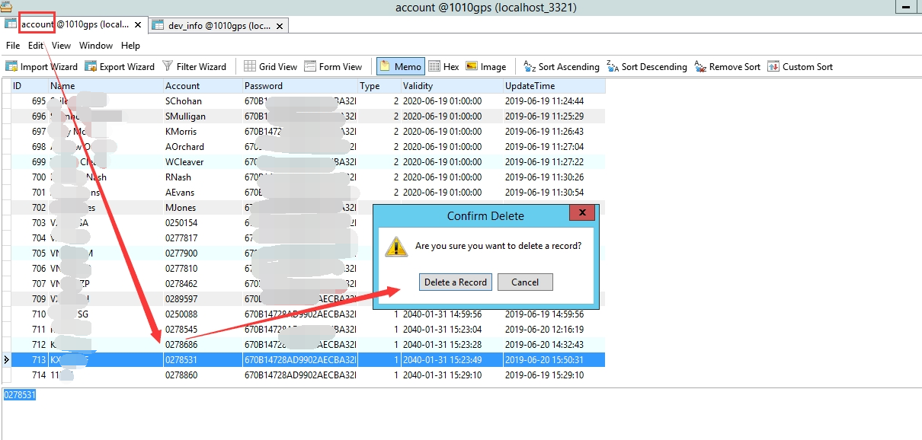

- After change this, then restart the IVMS Server and try to add device or user from the server web page again, you will find it is working now.

