How to get the GPS location in Web Report

1.First, stop the IVMS Web Server, then open the IVMS Server installation directory, use the new file replace these four files.

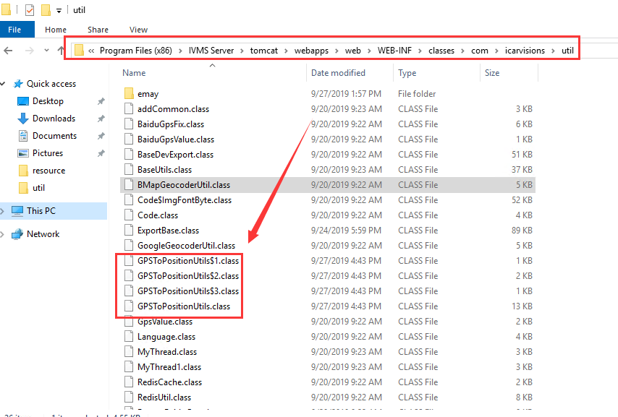

2. Find the Map.properties file open it, then change the Google API and other settings.

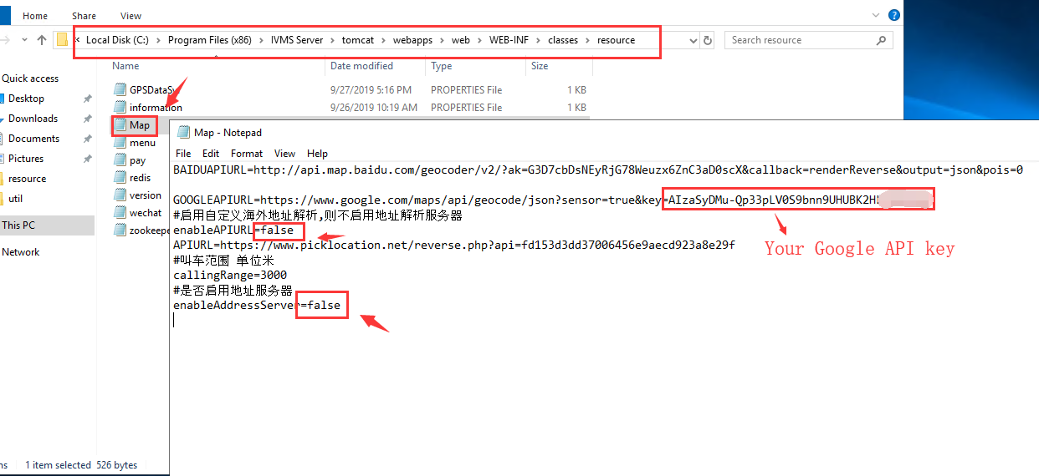

3. Restart the IVMS Web Server, then you can see the report GPS location.

