1. First, open the IVMS Client installation directory, find the libconfig_default.dll file, then use the new libconfig_default.dll file replace the old one.
Like: D: \IVMS\Client\plugin\config\libconfig_default

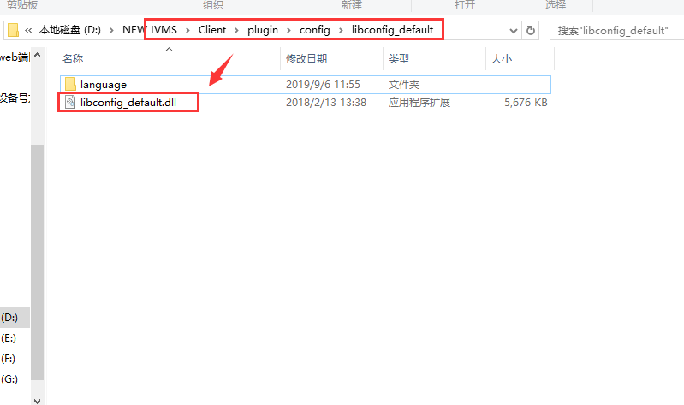

2. Find the config file to change the AllowChangeDeviceInfoSetIDNO=1, then save it.

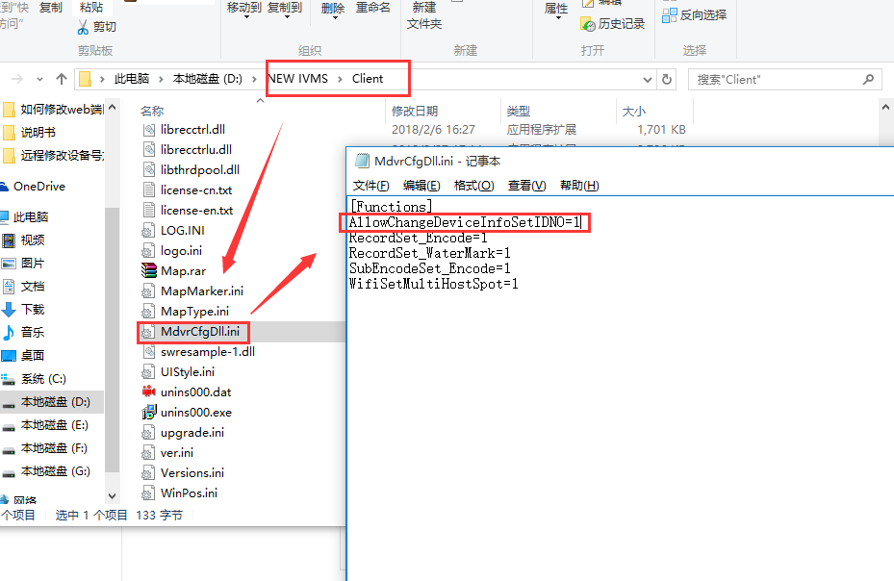

3. Restart the IVMS Client, then you will find change Device Num function in the Parameter configuration.

