How to Add Card Reader to DVR
There are five steps to get Card information via IVMS Client and reports.
1. Connection about cable. Please make sure the cables are connected correctly like the below picture.

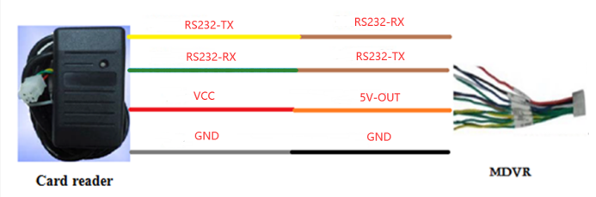
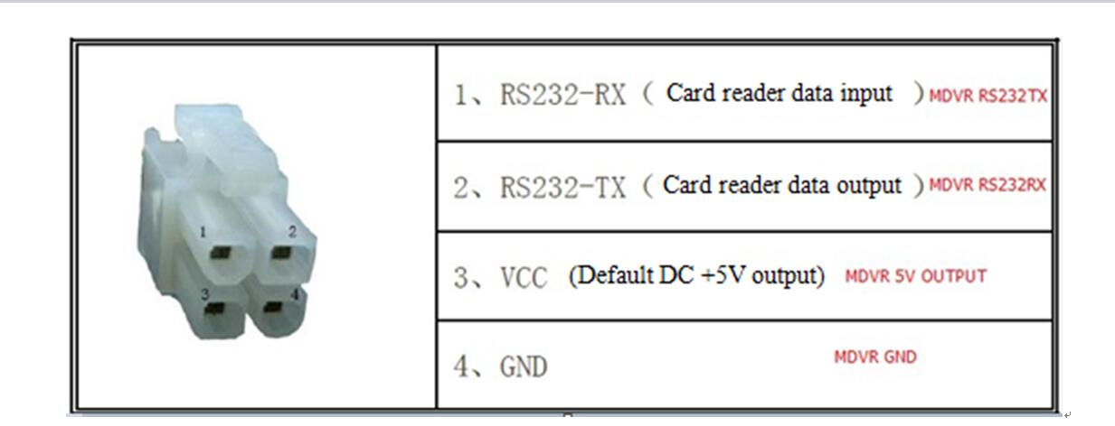
2. Configure parameters in MDVR. Please configure the parameters about COM2 if you select RS232-2.

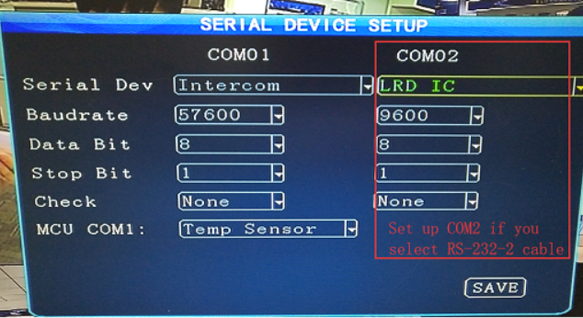

3. Write info into IC Card. There is a Card Writer and a software.

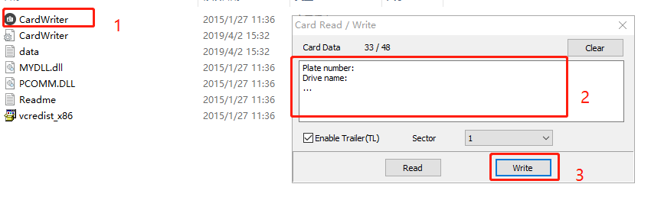
4. The IVMS Client can show the info when the card is swiped. The info include Plate number, time, location and content.

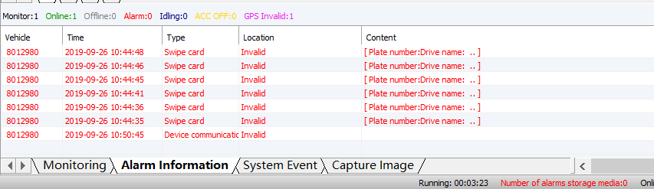

5. There are also a report for you to export to Excel.

