How to fix the Andorid APK Google Map problem
1. Open the file, unzip the google-mobile.rar, then copy it to the installation directory, such as:
D:\Program Files (x86)\IVMS Server\tomcat\webapps\gpsweb\client\Map

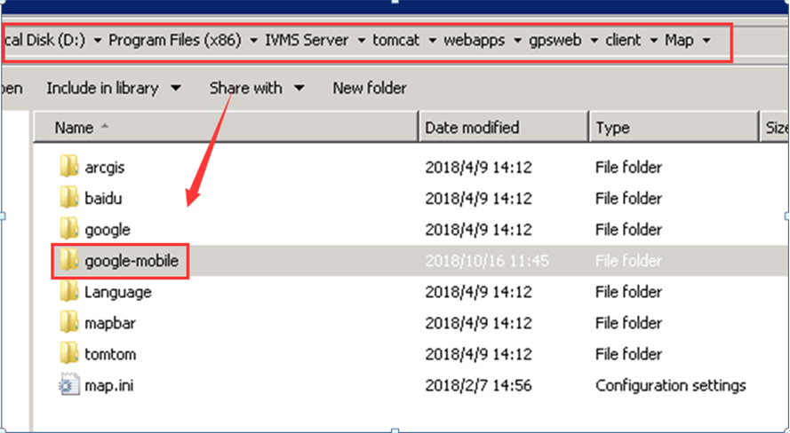

2. Open the google-mobile folder, change the gmap_cn.html and gmap.html, put your API key to this place, then save it.

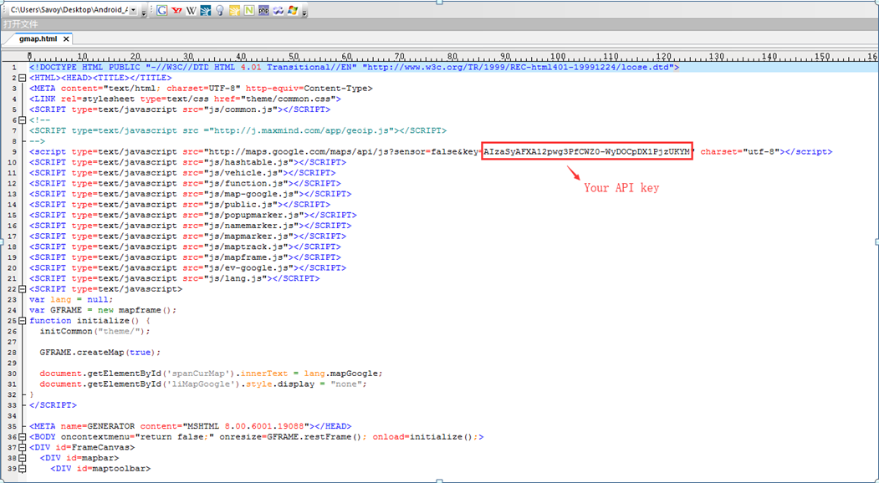

3. Restart the server and install the new app version from Google Play to test.

