​How to get Mobile DVR Wifi online
1.First confirm the information of your wifi hotspot, such as SSID and Password. And then go to the MDVR side to config the settings for wifi connection. For the GetIp Mode, you can use it DHCP like the first picture, but if you want to use static IP to connect the wifi hotspot, you can set it like second picture, but make sure the IP address is support by your wifh hotspot, and the IP address is not occupied by other devices inside you wifi area. Another point is the encrypt, auth mode, encrypt type, please follow the settings of the picture.

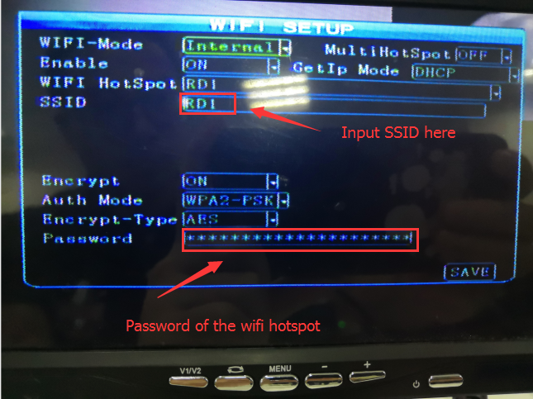

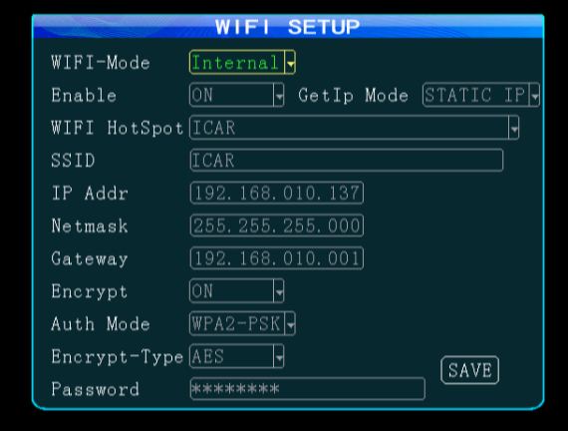

2.This step is teaching how to connect the device to the IVMS Server. First input your device_ID number on the vehicle info page. And then make sure your IP and port of the IVMS Server, input them on the network setup page.

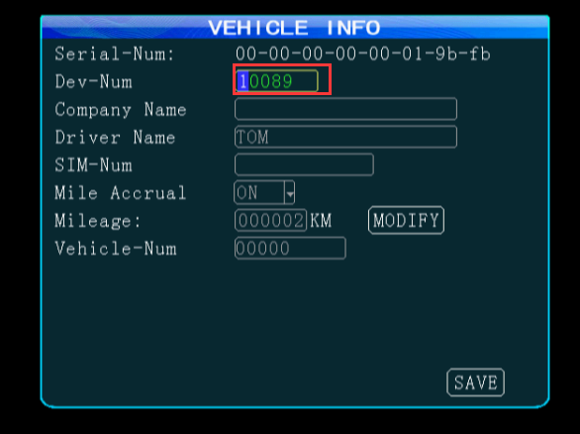
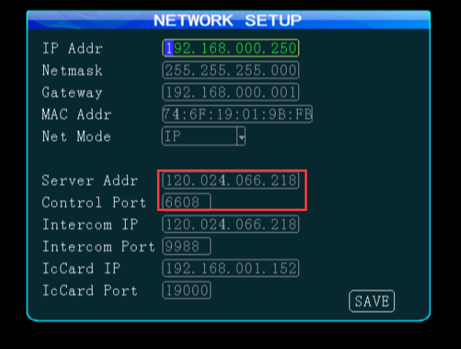

3. Go to the system info page and check the status of the wifi and connction with server. When WIFI-sign shows OK, and Center-L shows SUCCESSFUL, it means the deivce connect to the IVMS Server successfully.

