How to set GEO Fence alarm on new IVMS Client
1. First, you need to draw a GEO Fence in IVMS Client side, you can draw a rectangle, polygon or circle in the map.
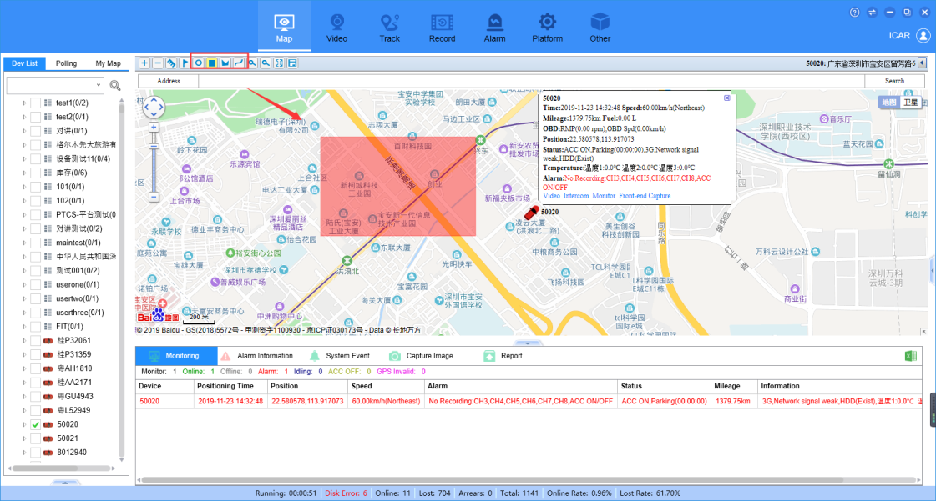

2. Input the Fence name, and choose the type to save it, then it will show in this side, if you add a wrong Fence, you can choose it to delete it.

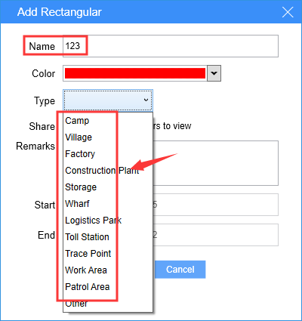
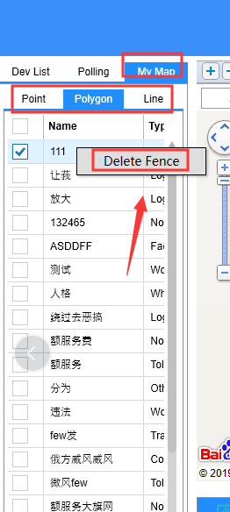

3. Login the web to config the GEO Fence alarm, choose Platform--Fence Alarm--Config Fence alarm to set it.

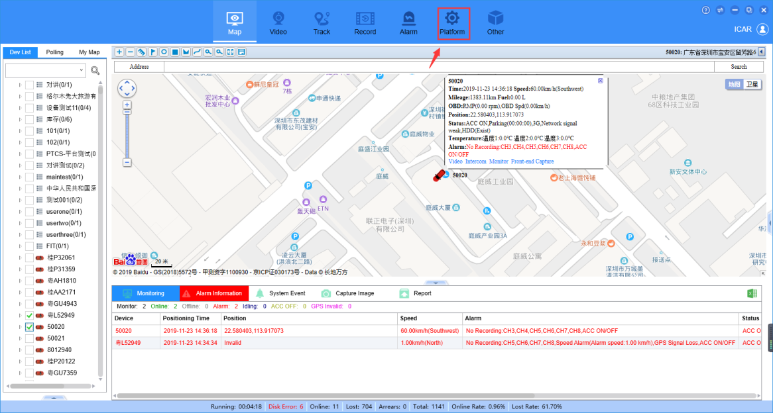
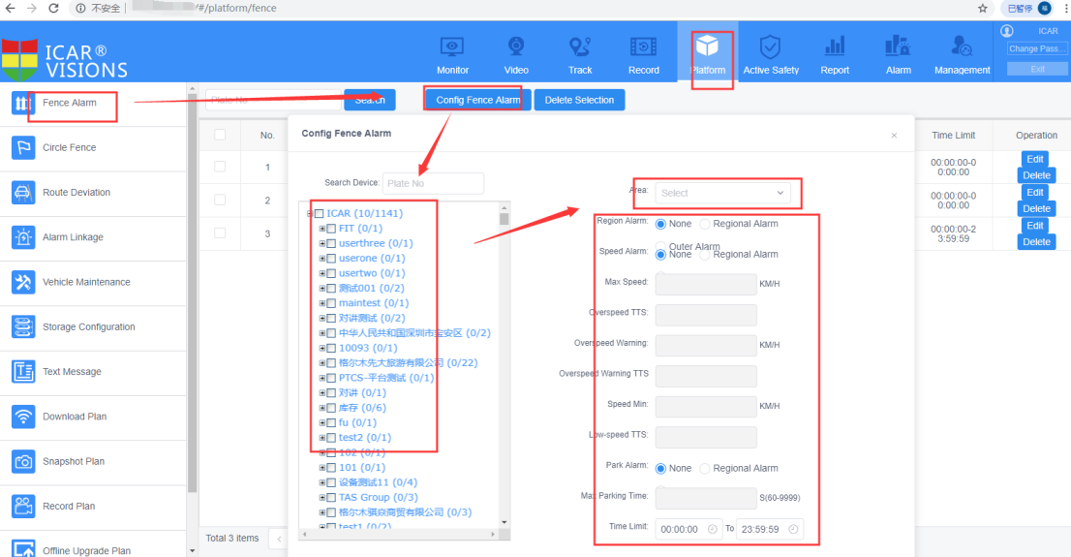

4. You can set In/out fence alarm and Speed alarm in/out fence, then we the device In/out the fence, it will send alarm to the platform, and you can check the report in this side.




