Check the MDVR Parameter through Google Chrome
Here is one way to check the MDVR parameters through Google Chrome When your MDVR connect WIFI and select DHCP.
You need to access to the IP which was assigned by the Hotspot.
You can refer to the way.

1. MDVR connect WIFI and show OK.

​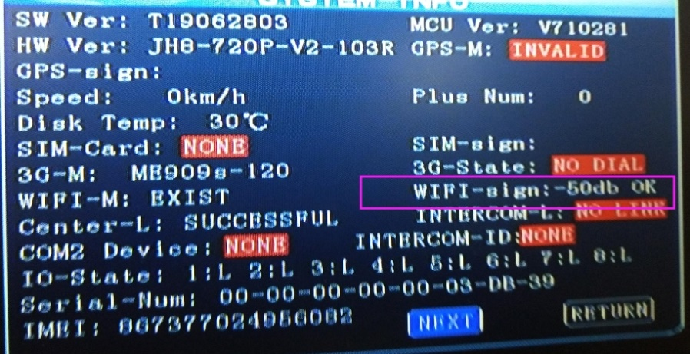

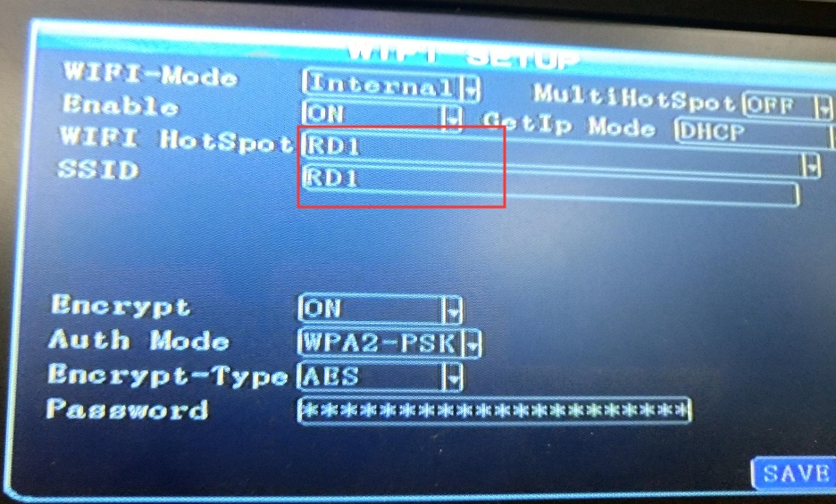

2. Get the IP from CRT or something else.

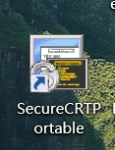
ifconfig

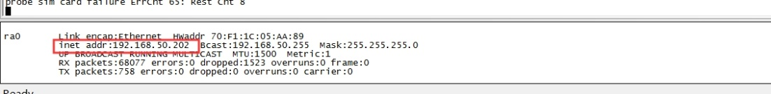

Note : This IP is your Hotspot assigned to your MDVR, is not the local IP.

3. Your PC connect the WIFI. Check the WIFI Property.

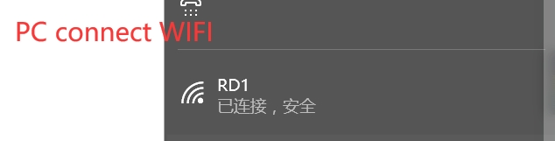

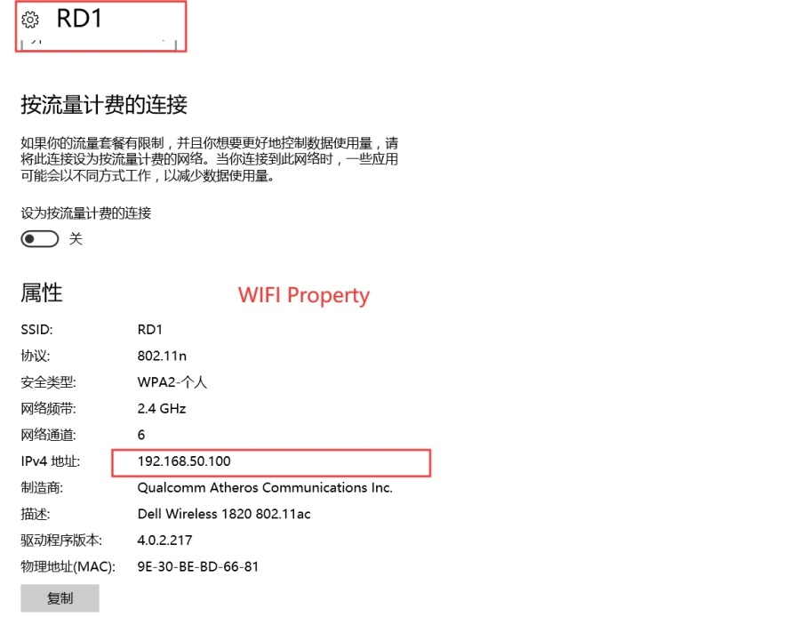

4. Surf the IP which your Hotspot assigned to your MDVR.

