How to change the camera parameters at MDVR side

1. First, power on the MDVR and use the remote control to choose a single channel, like CH1.
2. Click F2 button at the remote control, then it will show the camera parameters, HUE is chroma, LUM is brightness, CONT. is contrast, SAT. is saturation, SHARP. is satiety.
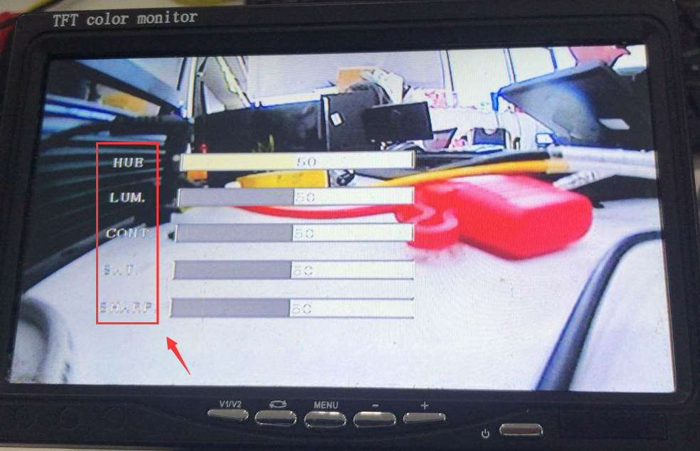

3. Use "+,-" to set the camera parameters, then the camera video will change after you change it, also it will record to the video.
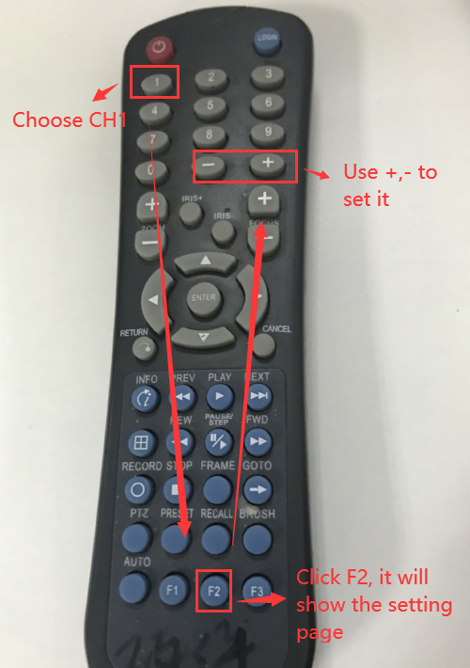
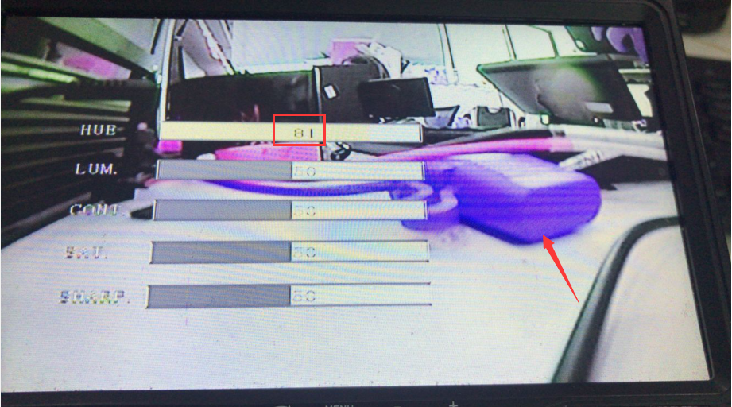

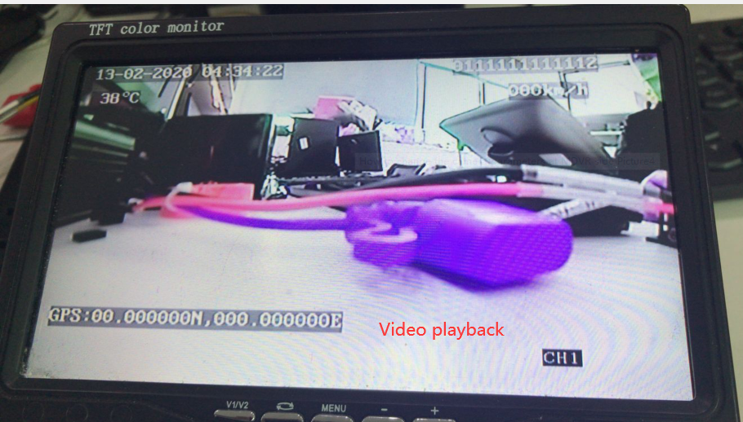

4. If you want to reset the camera parameters, you just need to restore the MDVR to factory default.

