How to solve login Serverr failed issue
There are three phenomena about login Server failed, include ICARVIEW login failed, IVMS Client failed, WEB login failed.
1. ICARVIEW login failed;

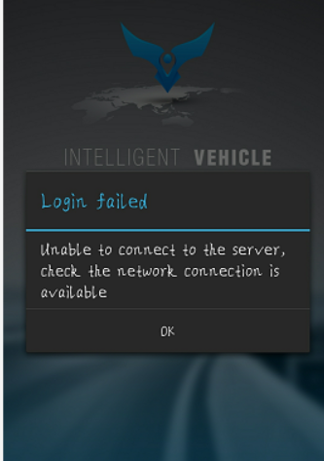

Please make sure that the account, password, Server IP, web port are correct. The most important thing is the web port. If your Server web port is 80, you can only fill in IP, but if it was 88, 8080 or 8088, you have to fill in like this IP:web port.

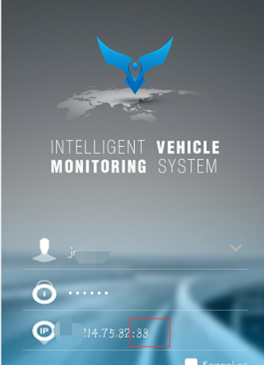

Login successfully.

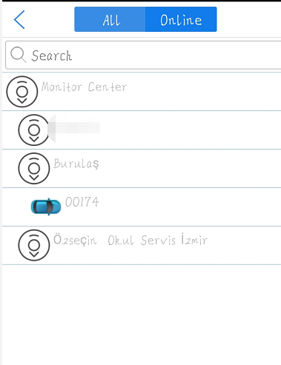

2. IVMS Client failed;

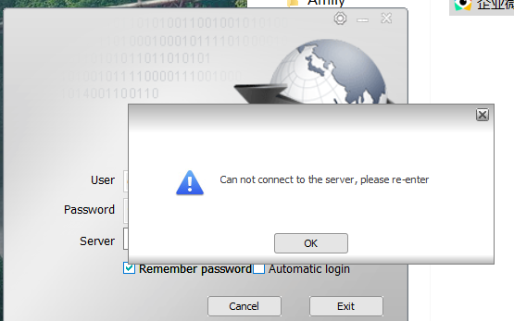

Please make sure that the account, password, Server IP and web port are correct. The most important thing is the client port. Please make sure the port is 6603 or 6605.

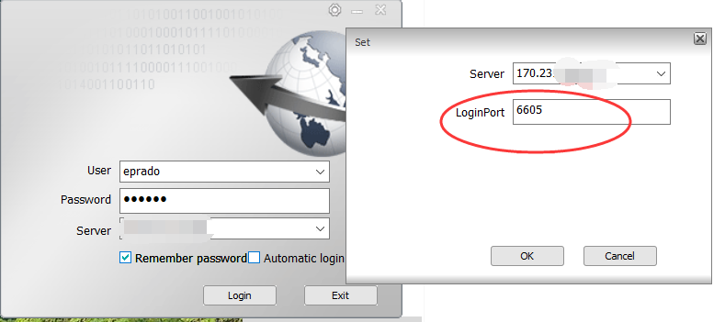

login successfully

3. WEB login failed.

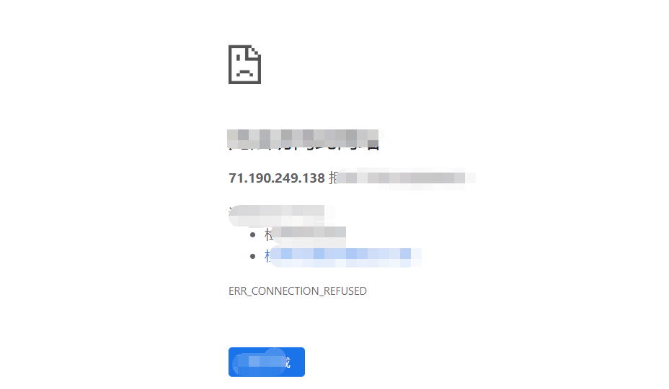

Please make sure that the account, password, Server IP and web port are correct. The most important thing is the web port.
If your Server web port is 80, you can only fill in IP, but if it was 88, 8080 or 8088, you have to fill in like this IP:web port.

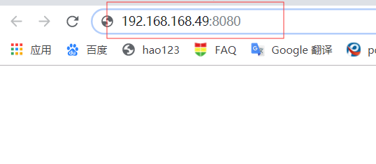

login successfully

