Remove the error prompt about 'JavaScript API not support your browser'
Remove the error prompt about 'JavaScript API not support your browser' in the map side.

For old IVMS Client:

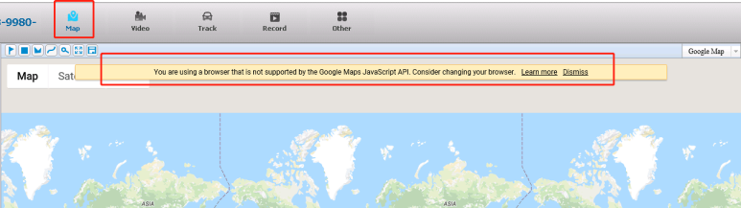
​
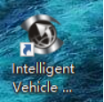

1. Here is the links about the standard IVMS Client, which had solved this issue. You can install it directly if your IVMS Client is not Customized.
https://www.dropbox.com/s/vbu4k9agt4wc9i8/IVMSClient_WIN_8.20.1.2_20200102-std.exe?dl=0

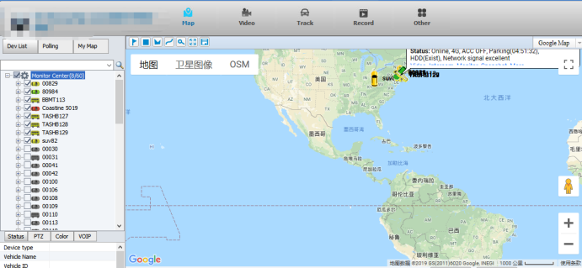

2. If your IVMS Client is Customized version, you just need to download and put these files in the path as below to solve this issue.
https://www.dropbox.com/sh/dm5hu7liubhuho9/AAAO02Deuib1H-IanZ2dQzo8a?dl=0

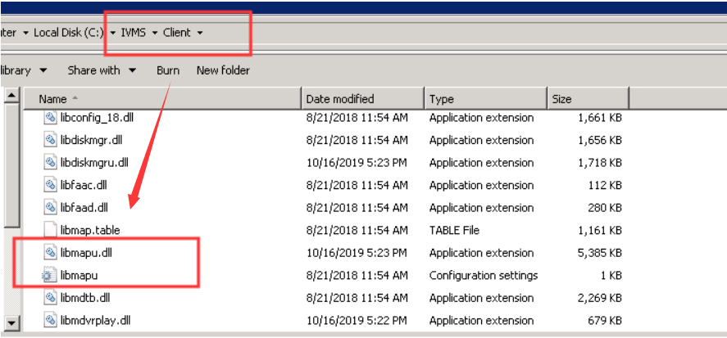

For new IVMS Client:
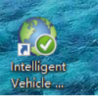

1. If your IVMS Client is not Customized version, you can download the new standard version,which had solved this issue from this link:
https://www.dropbox.com/s/qgpix4g6q24e72c/IVMSClient_WPF_WIN_7.19.9.6_Current.exe?dl=0

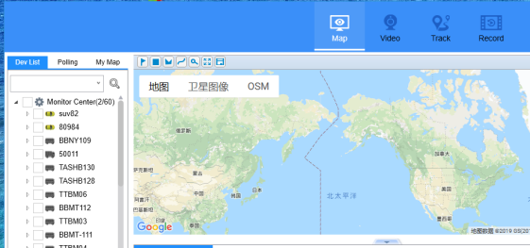

2. The new version's map is get map from server side as default, if you want to set it get map from local side, you can change it in this side, then restart the client.

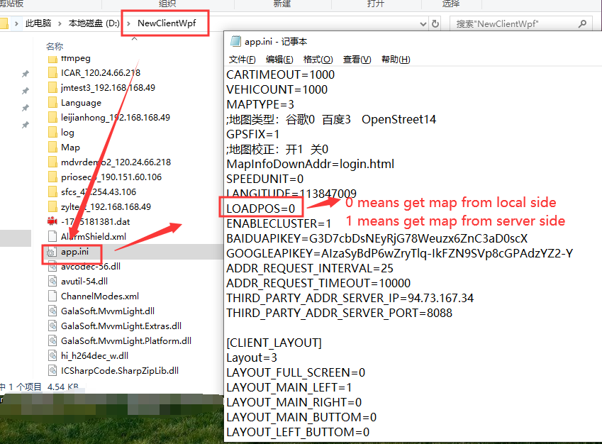

1) If you select 1, it means get map from server side. you need to replace the Map folder in server side, this path "IVMS Server>tomcat>webapps>web>client". Here is the new map folder, you can download it from this link:
https://www.dropbox.com/s/07nmdrtbwe08vlm/Map.zip?dl=0

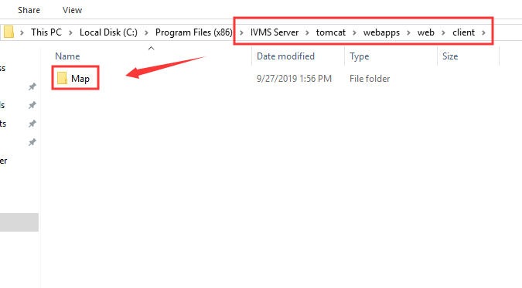

Then add your Google map API key to this place, save it and restart the IVMS Server and IVMS Client.

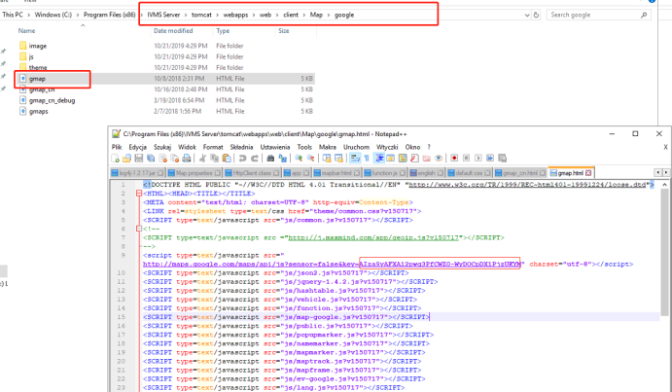

2) If you select 0, it means get map from local side, you just need to add the google map API key in this side, save it and restart the IVMS Client.

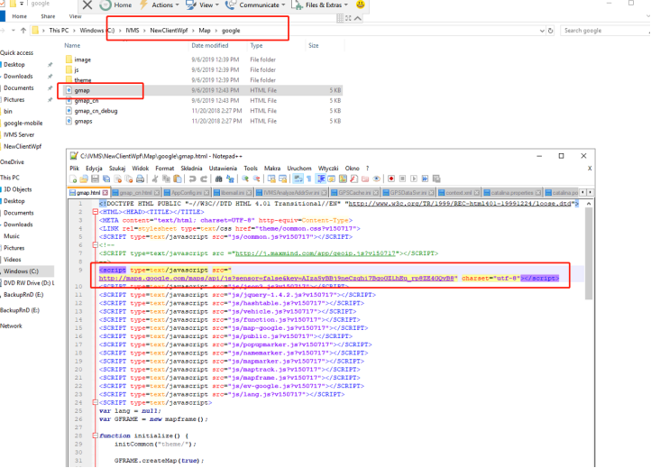

3. If your IVMS Client is Customized version, you just need to download the new MAP file, and replace it, you can download it from this link:
https://www.dropbox.com/s/07nmdrtbwe08vlm/Map.zip?dl=0

1) If your client is get map from local side, you just need to replace the new map file to this path "IVMS>NewClientWpf>MAP" , then add the google map API key,same as the standard version.

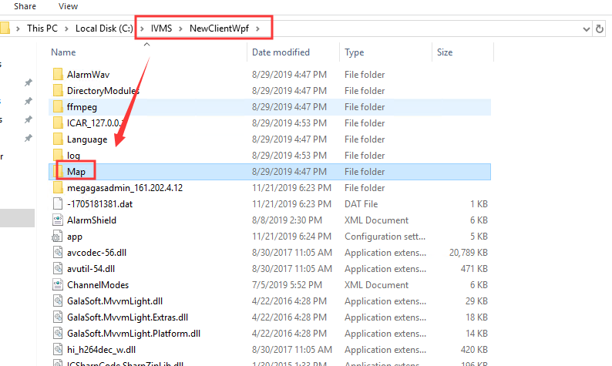

2) If your client is get map from server side. you need to replace the Map folder in server side, this path "IVMS Server>tomcat>webapps>web>client".,
then add the Google API key, and restart the IVMS Server and IVMS Client.

