How to Fix the Web Client can not Support more than 6 Channels
1. When you login the web client, you can find that when you open more than 6 channels, it will not support the channels that exceed 6 channnels to get the video.

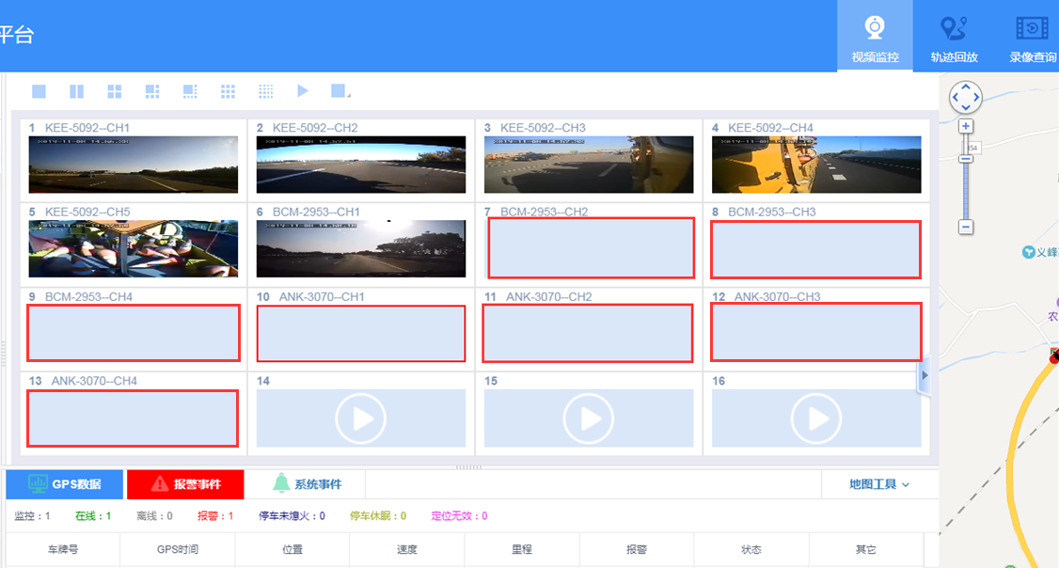

2. The reason is because that the maximum concurrency limit for browser and domain name requests can not exceed 6. So need add more ports to support these videos request. The new IVMS Server defaultly add 16604-16609 for the request. So need add these ports on the router and finish the port mapping. When finish mapping, you can login again the web client, don't need restart the IVMS Server.



