Search GPS Track Failed via IVMS Client
There is a phenomenon that old IVMS Client could search the GPS track, but the Intelligent Vehicle Monitoring System V7 failed.

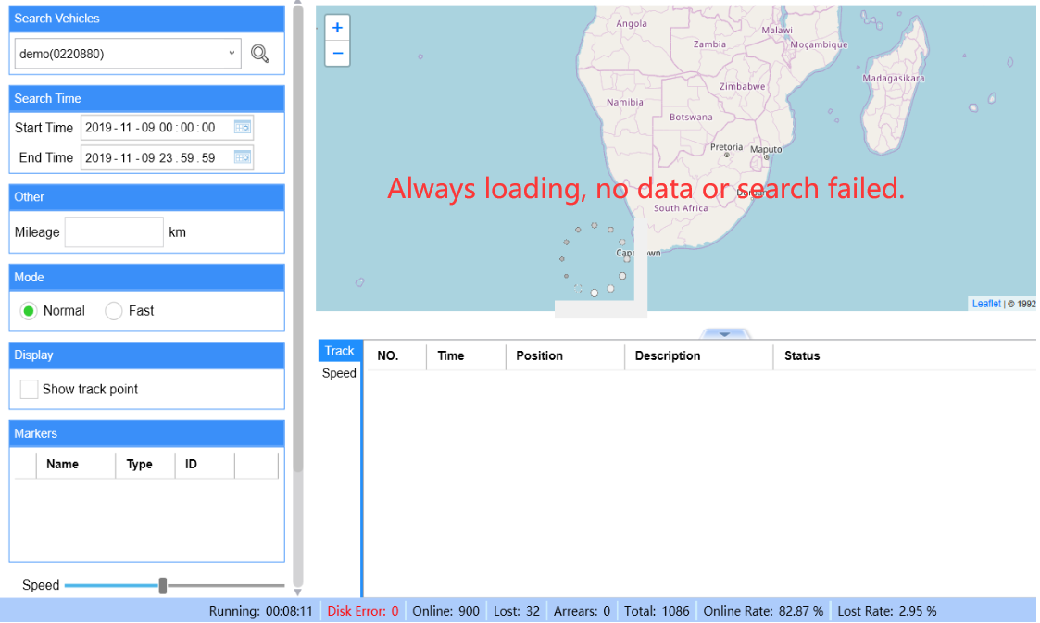

Here is one way to solve the issue.
Open the NewClientWpf.exe config file with a way you can edit.
Click "Ctrl+F" to find the <add key="AlwaysUseMongoDbForTrackSearch value=1>,
and change 1 to 0.

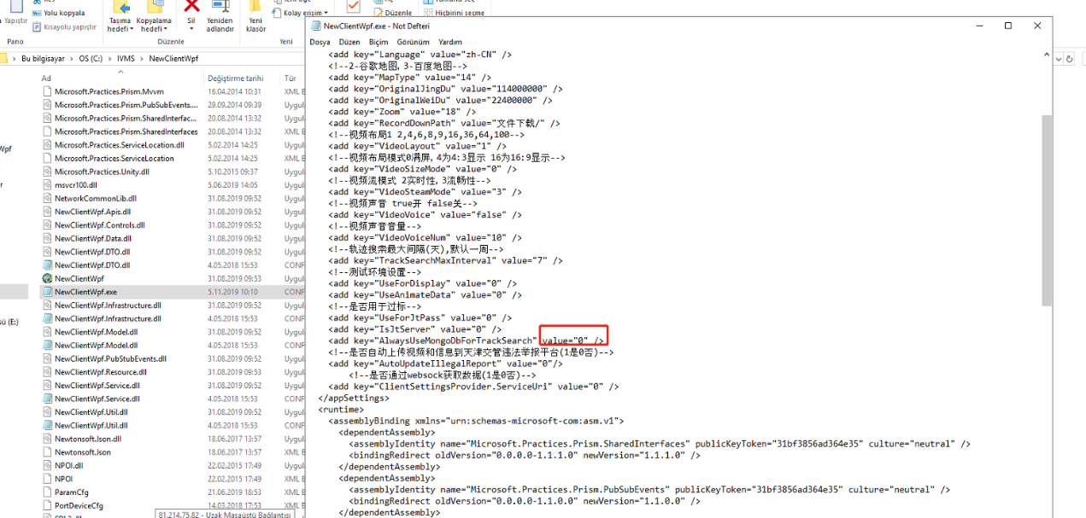

Then Restart the Intelligent Vehicle Monitoring System V7. You will search the GPS tracks successfully.

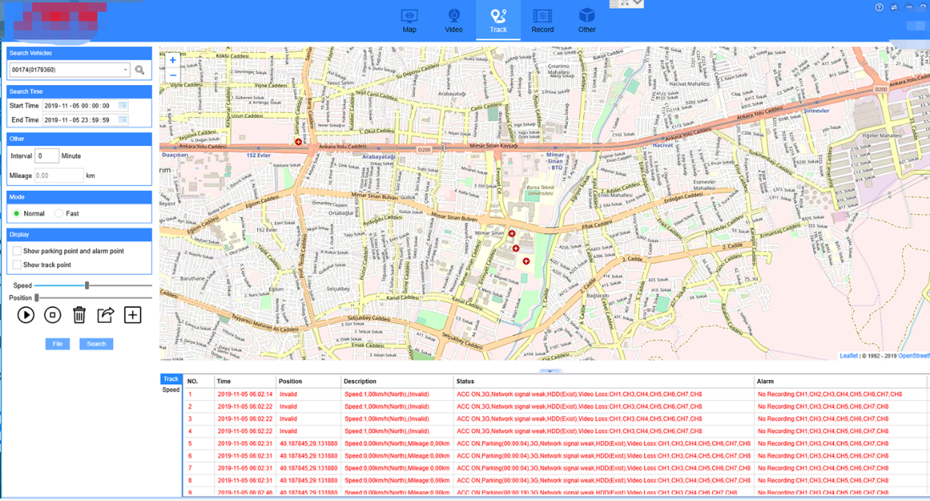

PS: The reason why the IVMS V7 search failed is that it dont get the data from MongoDB.
​

