How to solve the IVMS Client incomplete display problem

When we use the high resolution computer, we always get the IVMS client incomplete display problem, when we get this error, you can follow this step to solved it.
1. Close the IVMS client, and open the installation directory, find the config.ini.bak file, then open it.

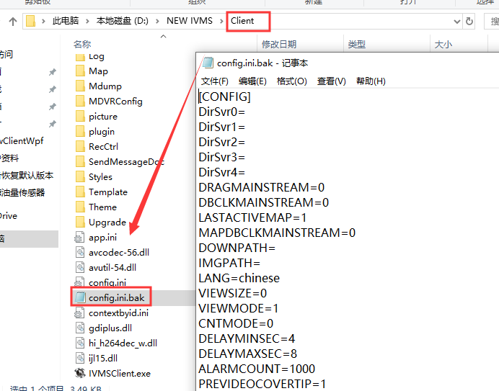

2. Find IS_SHOW_WIDTH_SET=0, change it to IS_SHOW_WIDTH_SET=1, then save it.

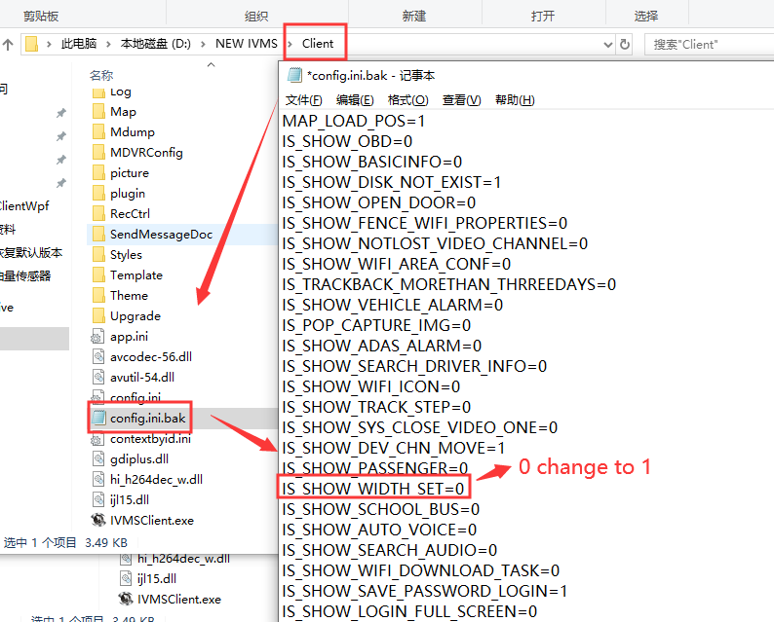

3. Restart the IVMS client, choose Other--System Setting--Other, then you can see the width show here, the default setting is 245, you can change it to a appropriate value, then save it.

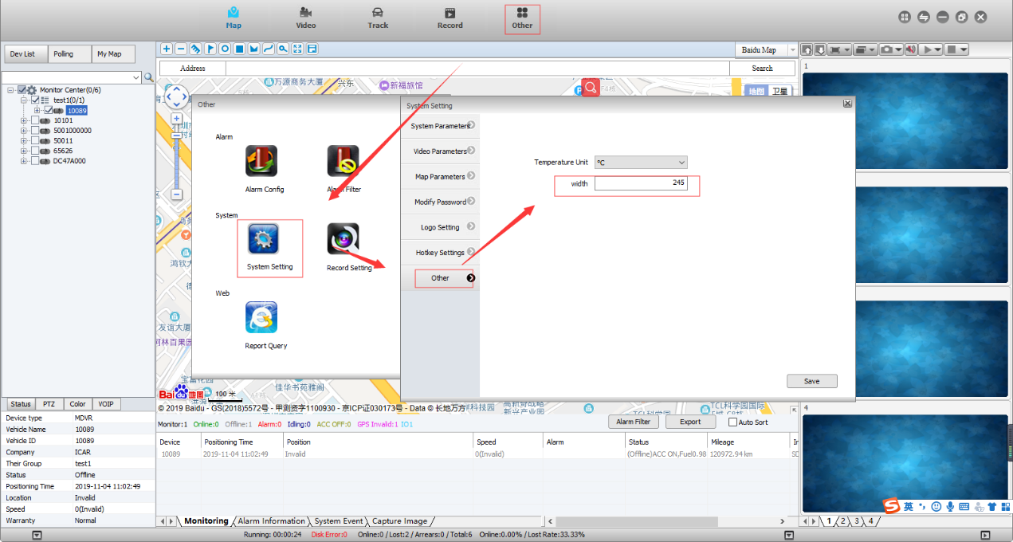

5. Restart the IVMS Client, and you will see it is working well now.

