Search GPS Track Failed via ICARVIEW

​There are two phenomena about the issue of Searching GPS Track Failed, one keeps loading all the time, the other shows "Track is empty" .

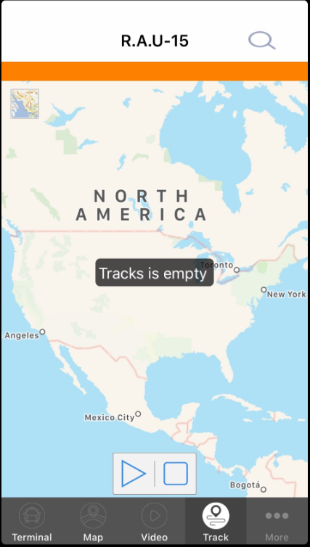

Here is one way to solve the issue.
Opening the GPSDataSvr wtih Notepad and delecting the sentence "SuBiaoADAS IP=X.X.X.X".

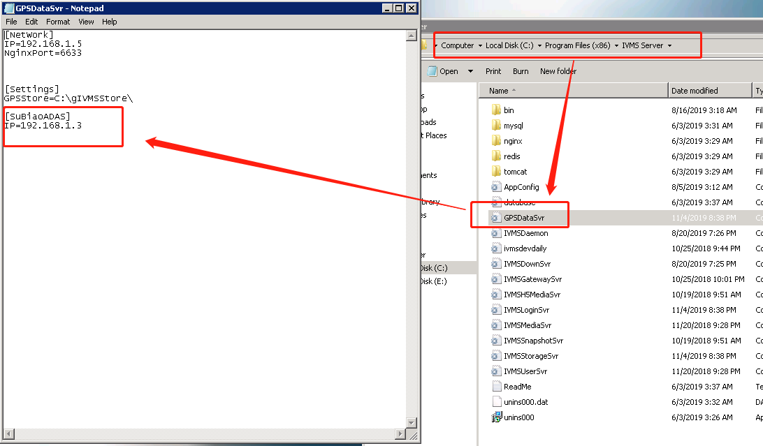

After the delecting the sentence。you would search the GPS track successfully.

