How to set the Android APK get map from server side

1. Open the file, unzip the google-mobile.rar, then copy it to the installation directory, such as:

D:\Program Files (x86)\IVMS Server\tomcat\webapps\gpsweb\client\Map

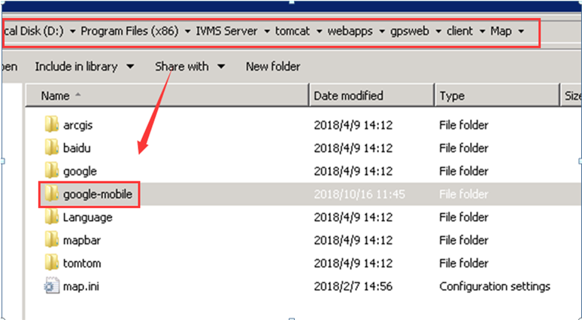

2. Open the google-mobile folder, change the gmap_cn.html and gmap.html, put your API key to this place, then save it.

3. Restart the server and install the new app version from Google play to test.

Android_APP_Google map updata-2018-10-16.rar

