How to connect Buzzer for Alarm out

1. Connect the Buzzer to the 24pin cable, the definition is as following.
GND(buzzer) connect to GND(mdvr)
5V(buzzer) connect to Senser out1(mdvr)

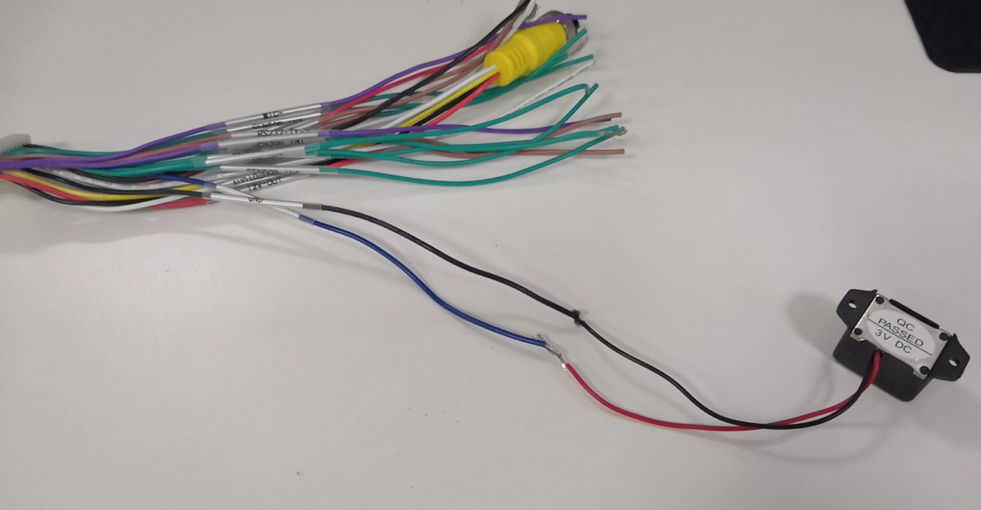

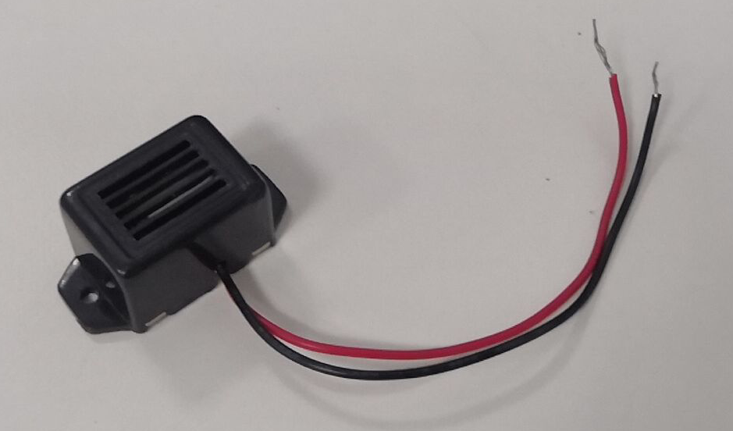

2. Connect the cables, and then connect 24pin cable to MDVR

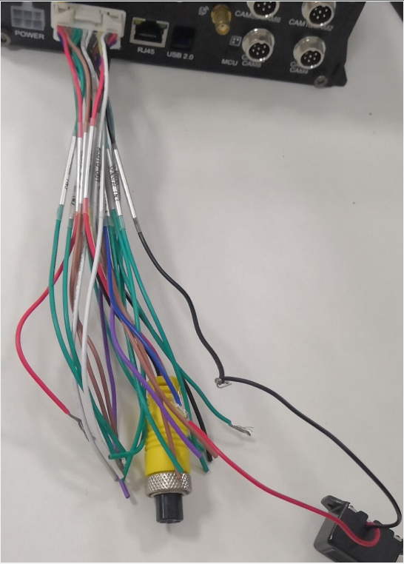

3. Then use the sensor in1 connect to 5V to trigger the alarm input.

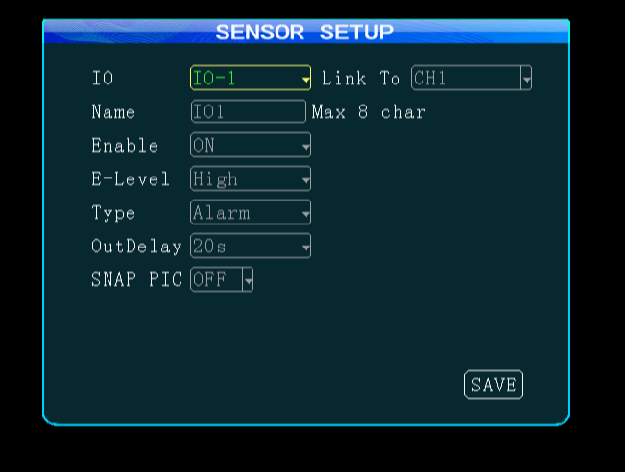

https://www.dropbox.com/s/lcr29o4q1e261l6/Buzzer%20Speaker%20Connection.mp4?dl=0
​

