How to Set Snapshot Plan on the IVMS Server

​1.Login the admin account on the web, and associate the device to the storage server.

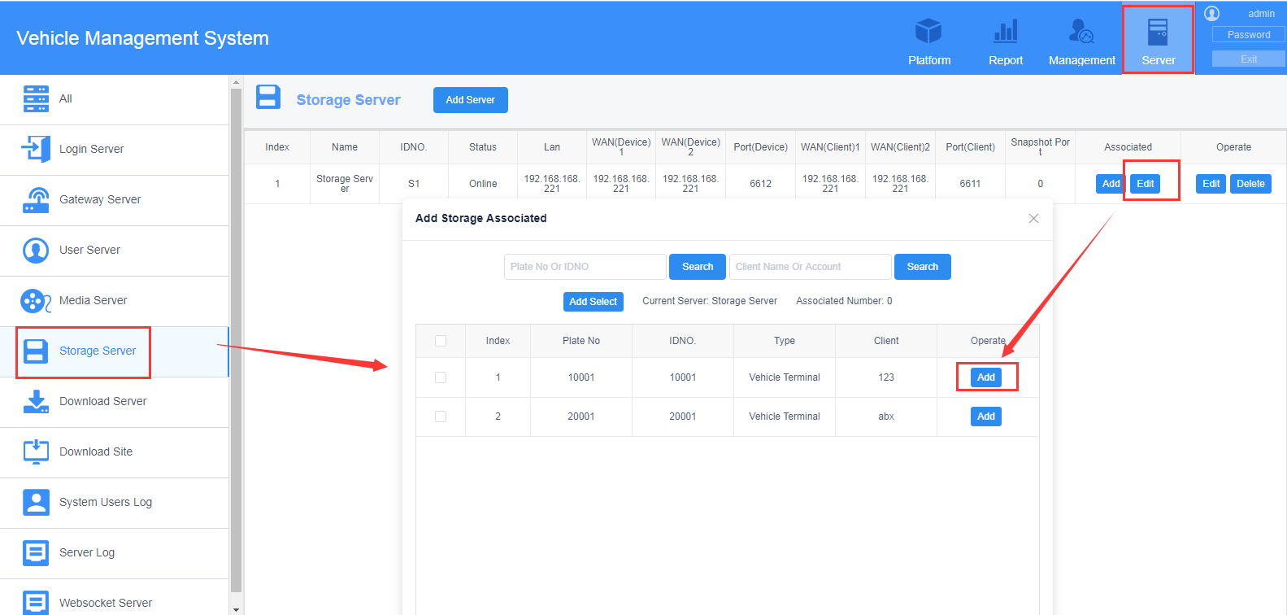

2. Enter into the user account and add snapshot plan.

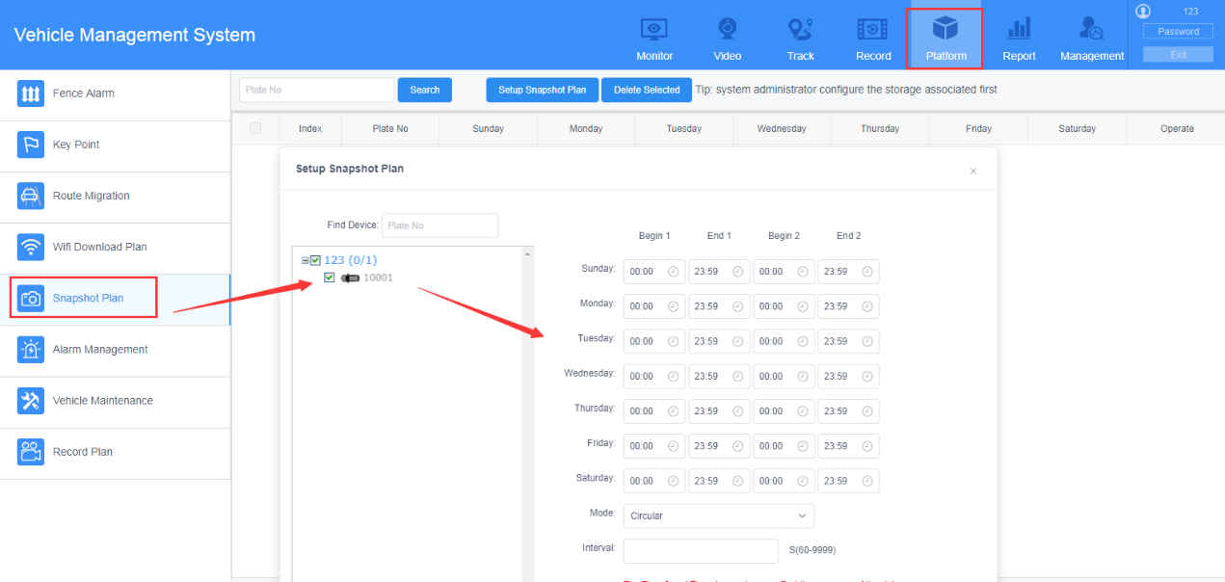

3. Check the path of the storage.

