How to change the GPS data storage directory

1. First, you need to stop the server, then open the server installation directory, find the GPSDataSvr.ini file.

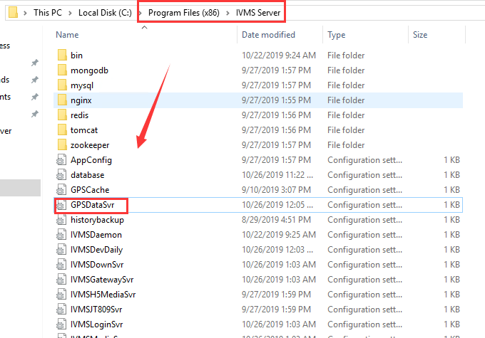

2. Open this file, and you can change the GPS data storage directory, the default setting is C:\gIVMSStore\

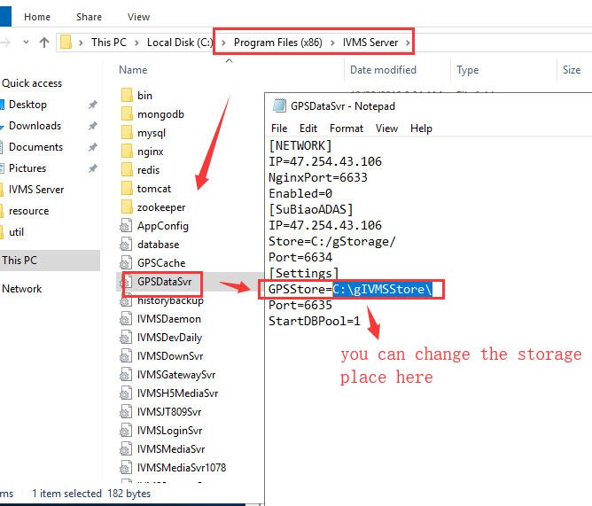

3. If you changed the storage place, you need to copy the old GPS data to the new directory you set, or you will can not find the old GPS date in IVMS Client side.

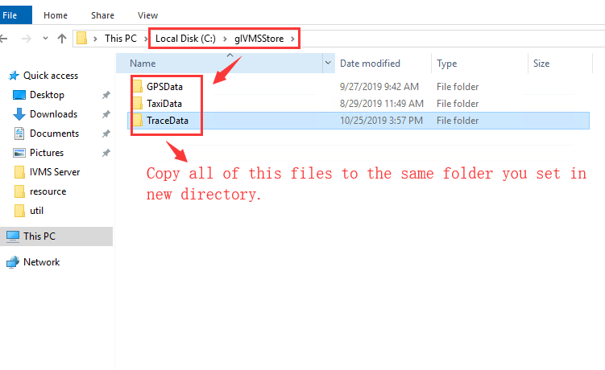
​
4. Restart the IVMS Server, then check if you can search the old GPS data from IVMS Client side.

