Executing Update too long when Upgrade IVMS Server

​When use the new version IVMS Server software update the former version, it shows like this.

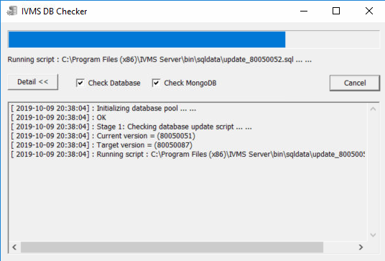

To solve the problem, need delete some datas, it's because database field of user is added repeatedly.
1. Connect to the database, normally the port of database is 3321 and the password is cmsserverv6. The tool is Navicat for MySQL.

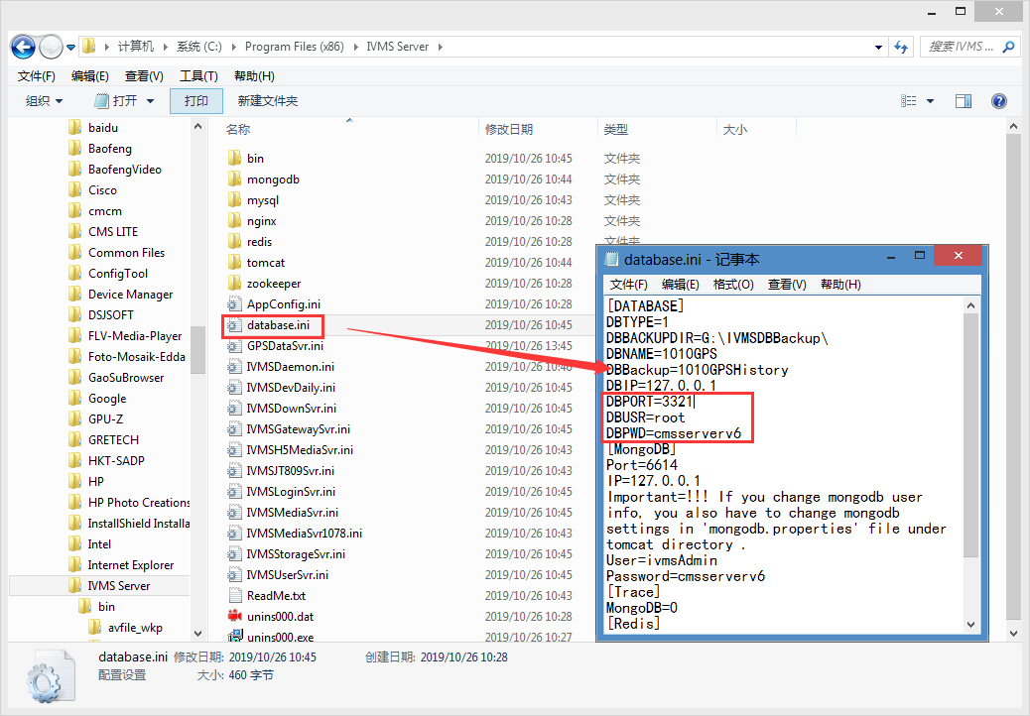
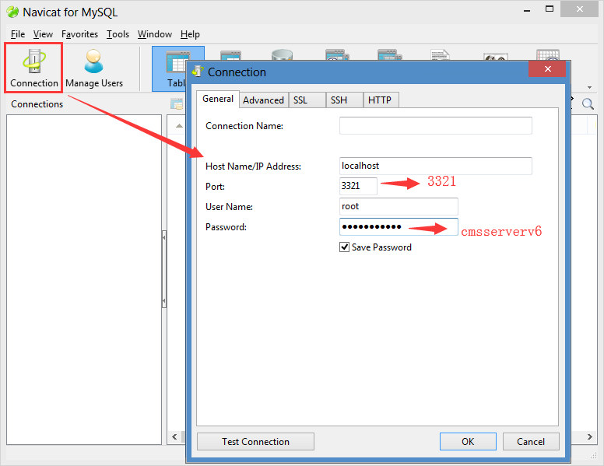

2. When connect successful, you can see the left list, and find the user_log table, delete some off them, normally for the IVMS Server, it will exist amount of user_logs, so when make upgrade for the IVMS Server, it will take a very long time, so when the issue happen, you can do like this.

