Temperature Sensor User Manual

​1.To set up the configuration of the MDVR
Firstly, login the device, and set up the MDVR by following steps. Choose the Alarm to set the temperature Alarm.

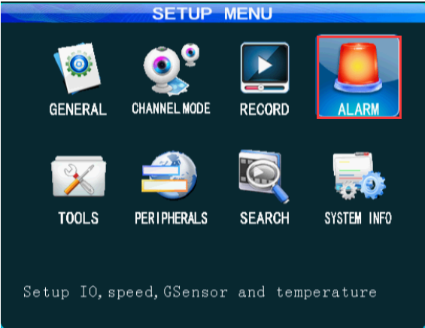
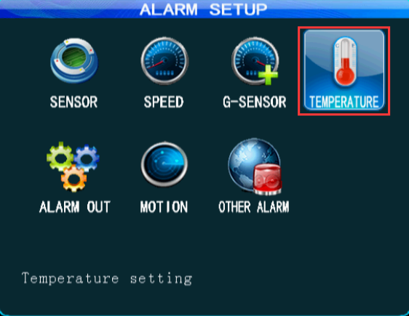
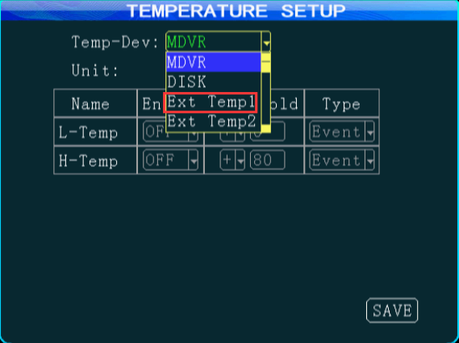

2.Choose the Temp sensor in MCU COM1,then save it.
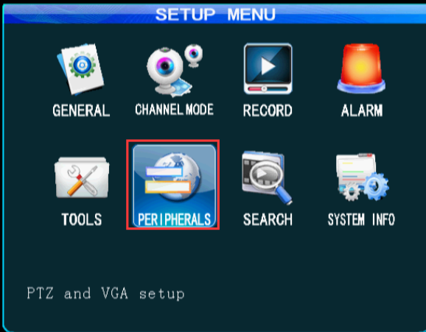
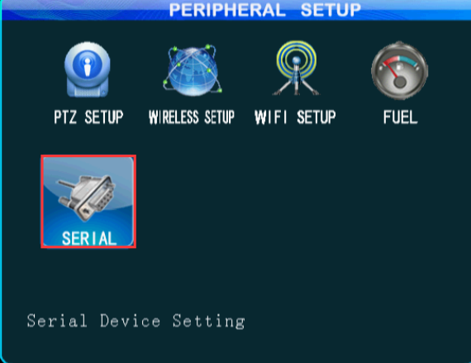
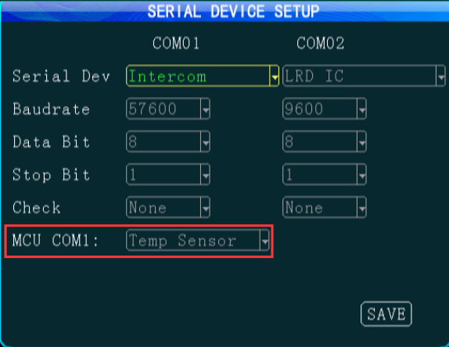

3. Set up the web application
Log into the web application, At Device-Vehicle Parameter-Edit-Temperature, and select the number and sensor. The temperature sensor 1 is for the temperature of device, the temperature sensor 2 is used for external temperature sensor 2, and the temperature sensor 3 is used for external temperature sensor 1.

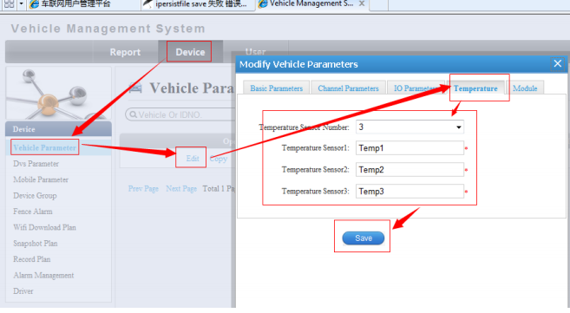

4. After successful settings, check the client
User can check the temperature value of temperature sensor (temperature sensor 3) at Status from Client. Also you can see the temperature in MDVR(System info).

