Passenger Counter Wiring and Testing

​Passenger counting system is based on one MDVR plus passenger counting instrument( mainframe and two cameras),first we need to connect MDVR's RS232-1 to passenger counting instrument's RS232-1(pic 1),then choose the JHY CNT in COM 1(pic 1),we can use passenger counting instrument's Sensor in(pic 3) to send the data to our IVMS client. About the passenger counting system how to work, you can check the instructions.

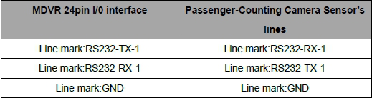
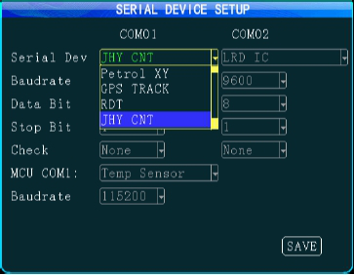
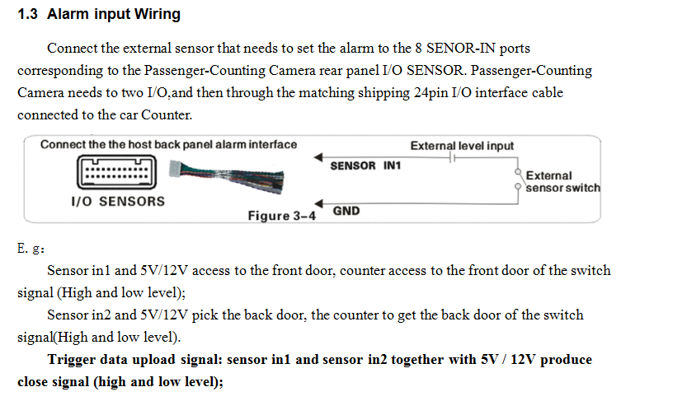
Note: When sensor1 and sensor2 touch 5v-out point line at the same time, will be reported once on and off data to the client and server reports.

