How to restore the IVMS Client account to default password
When customer use the IVMS account, they always forget the account password, then can not login and get this error,we can use this way to restore the password .
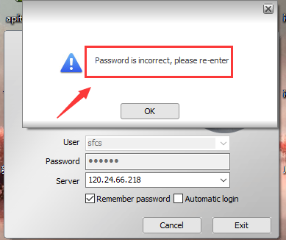
​
- You can restore the password from the web side.

- If your account are second level account, you can do like this. Open the server web, then use the first level account which above this account to login,and choose this place to change the password.
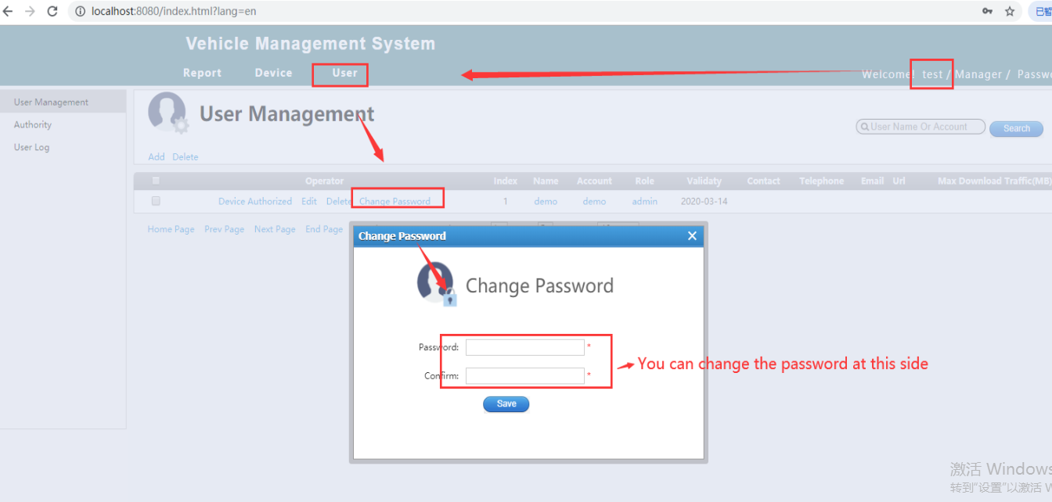

- If your account is first level account, you can use the admin login the web, then choose this place to restore the password.
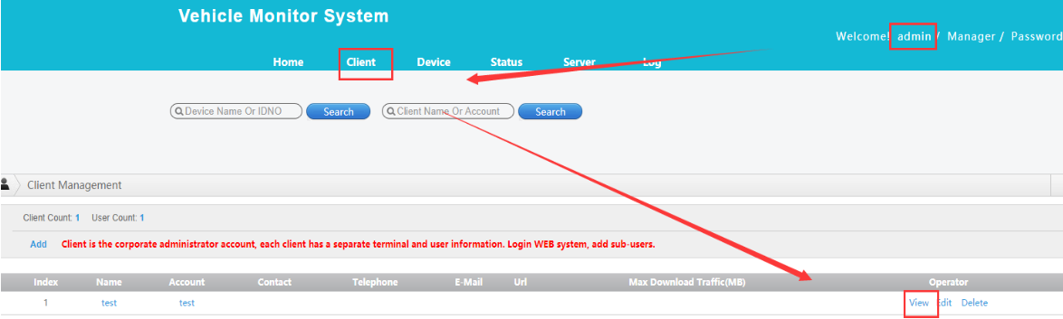
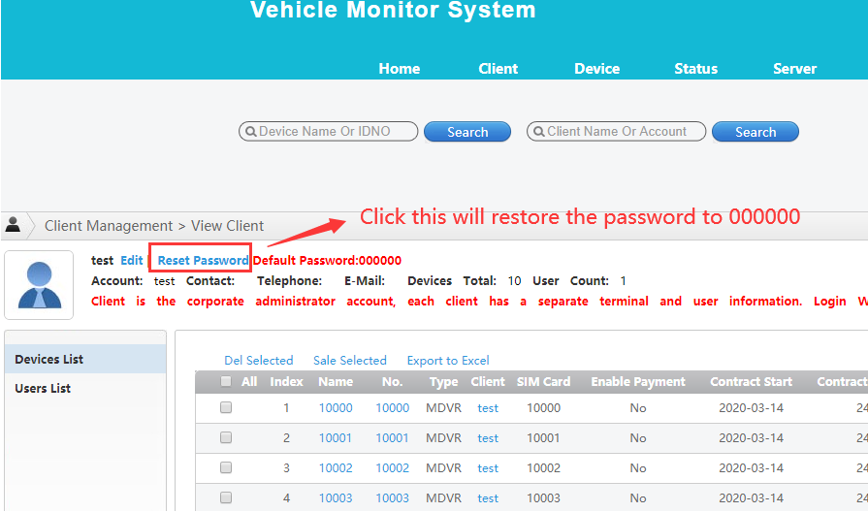

- After doning this, you can use the new paaword login again.

