How to solve the Gateway Server running failed due to the OS Error ID 7000

There is a phenomenon that the Gateway Server running failed due to the OS Error Event ID 7000 as below picture.
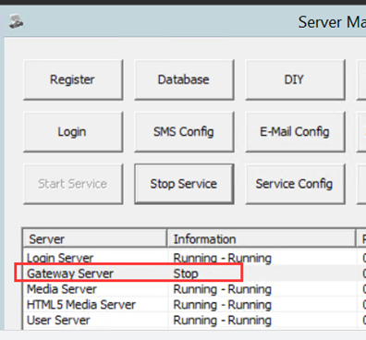
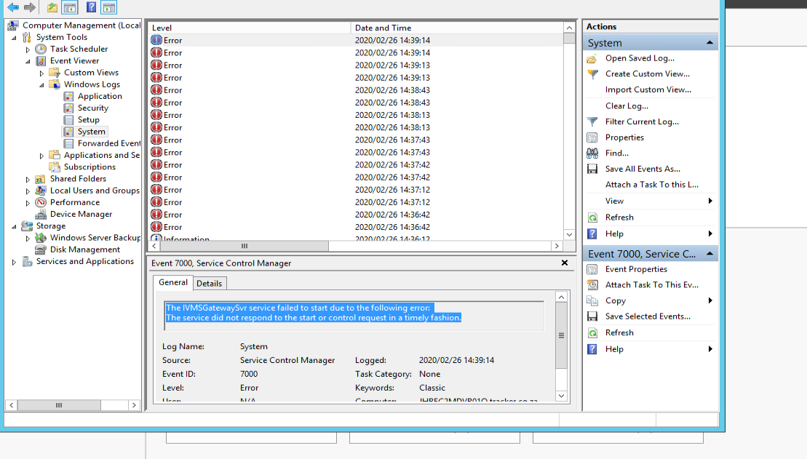
Please click “ Win + R ” and type “ Regedit ”.
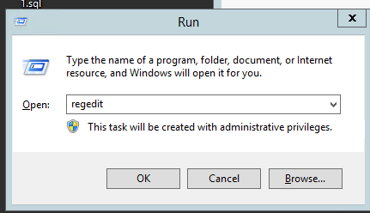

Double click the CurrentControlSet and click “Ctrl+ f”. Then type CldFlt.
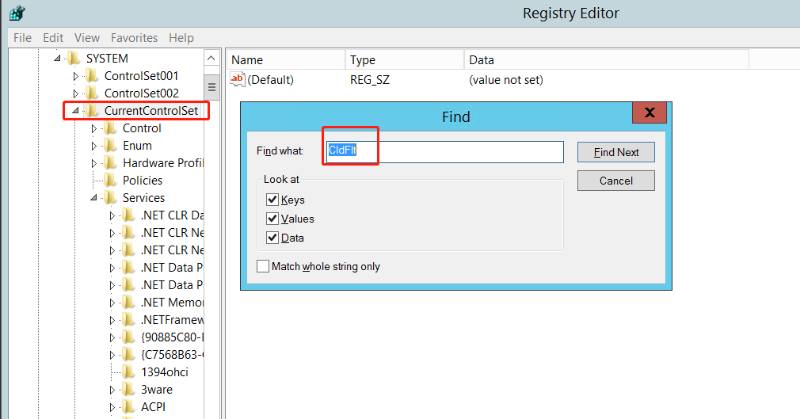
Change the value from 1 to 3.
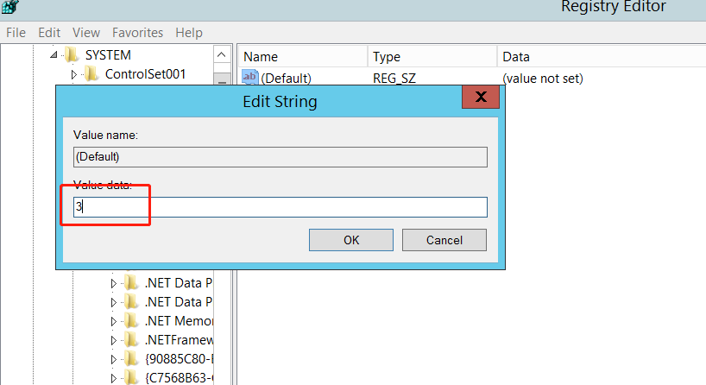
Then restart the OS.
After the steps finished, the Gateway Server can run normally.

