How to export counts data from Passenger Counter
- The default IP address of the Passenger Counter is 192.168.1.254, so before log in the client of Passenger Counter, need add one same segment ip address for the connection.
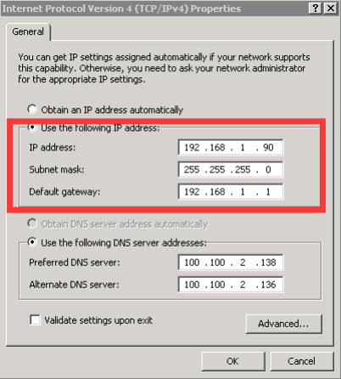
- Then after add the ip address, you can connect the network cable to the Passenger Counter’s RJ45 port. And another part connect to the PC network port, or switch, router. And then make sure the 192.168.1.254 is not occupied by other device inside the network. Then ping the ip address using cmd command to make sure it’s connected.
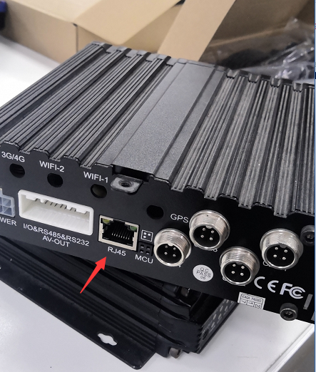
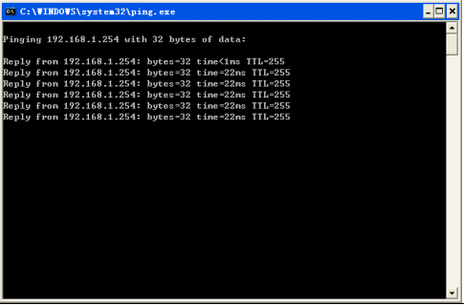
3.And then you can login the client of Passenger Counter, directly click connect on the login interface.
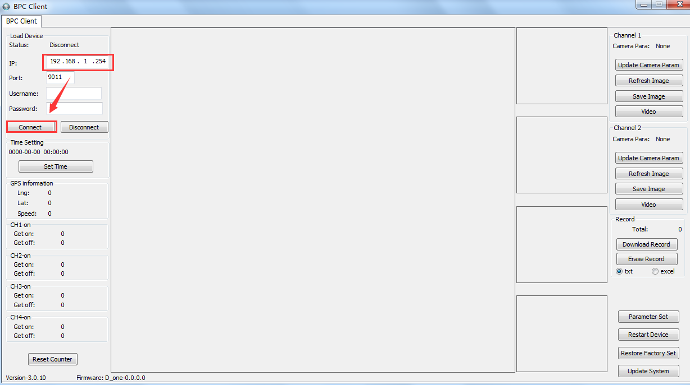
4.After login successful, you can see the right side, and left side, on the left side is the current data of passengers in/out. On the right side, you can see the Download Record button, click it and you will get the counts data.
