Update Passenger Counter camera parameter
If everything of the Passenger Counter has been checked, and the final reason is because the camera parameter is wrong.How could we check the parameters and change the parameters, here is the step that teaching what to do.
- The default IP address of the Passenger Counter is 192.168.1.254, so before log in the client of Passenger Counter, need add one same segment ip address for the connection.
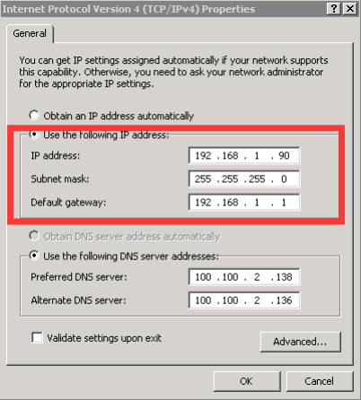
- Then after add the ip address, you can connect the network cable to the Passenger Counter’s RJ45 port. And another part connect to the PC network port, or switch, router. And then make sure the 192.168.1.254 is not occupied by other device inside the network. Then ping the ip address using cmd command to make sure it’s connected.
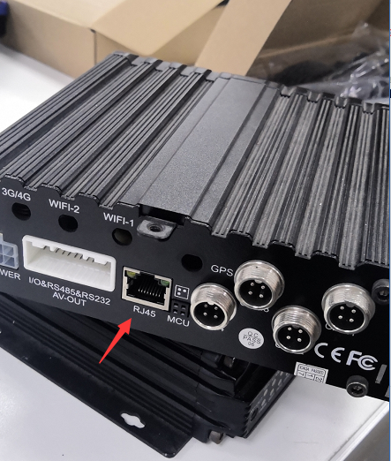
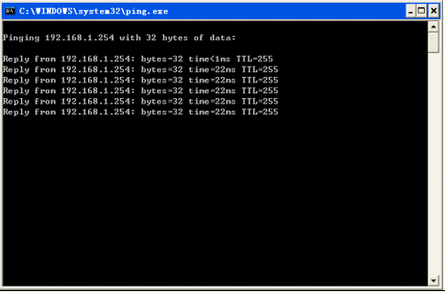
3.And then you can login the client of Passenger Counter, directly click connect on the login interface.
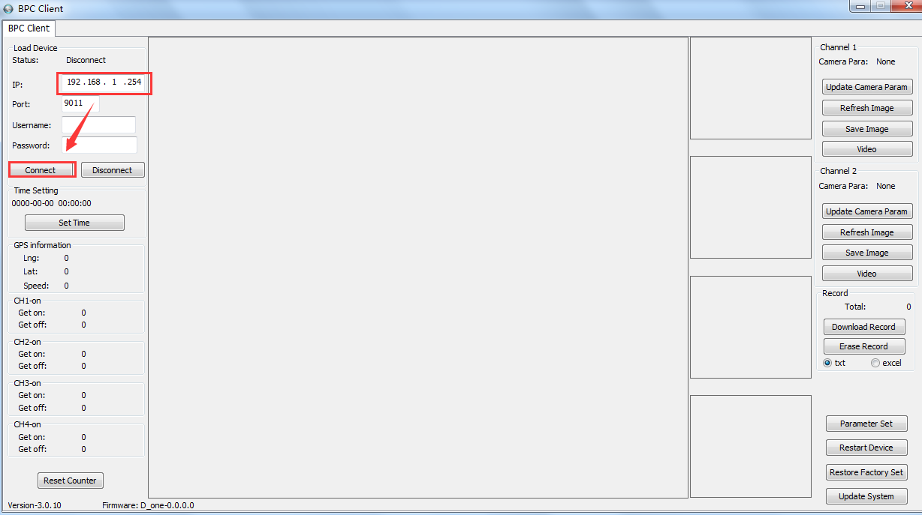
4.After login successful, you can check the camera parameters on the right side. And check the label on the cameras. Then send this information to our engineer, we will check and send the right parameter to you, and you can update it by the client.

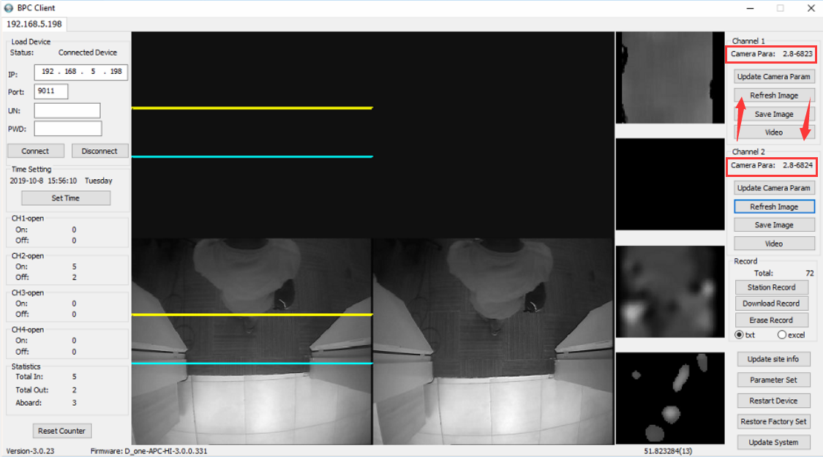
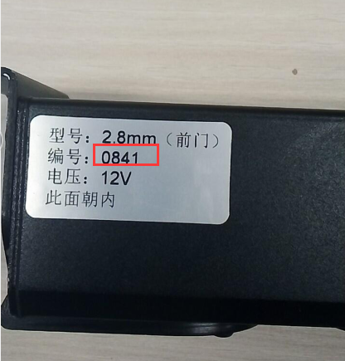
5.When you get the camera parameter, you can update it on the right side. And after update the parameter, restart the device.
