Passenger Counter with three doors

[Q]: Let me know the options you have to add person counter for buses with three doors.

[A]: Kindly follow the steps about Passenger Counter with three doors as below.

First. Here is the cables connection.

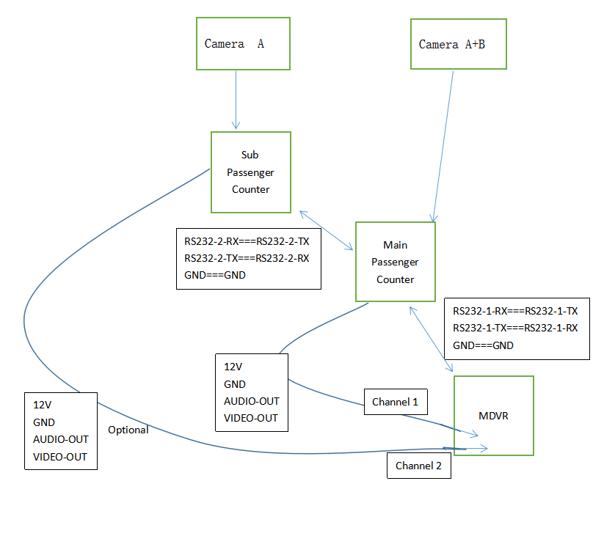
​
Second. Main Passenger Counter Parameters.

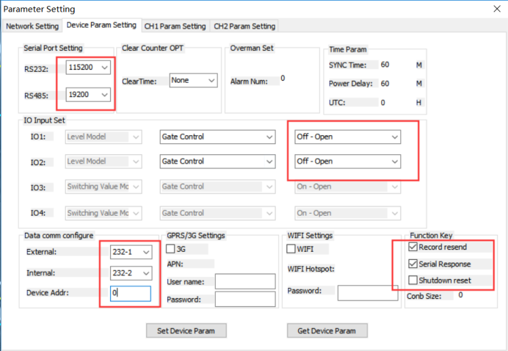

Third. Sub Passenger Counter Parameters.

