How to connect the power cable

​For the power cable, it is a 6PIN cable, the red and black cables are directly connected to the battery of the vehicle, i.e. positive terminal and negative terminal respectively. The yellow cable is connected to ACC, the vehicle control circuit switch (used to start the vehicle motor). The unit will be enabled automatically when the car key is enabled and disabled when the key is disabled. This is the JH4-HD interface definition.

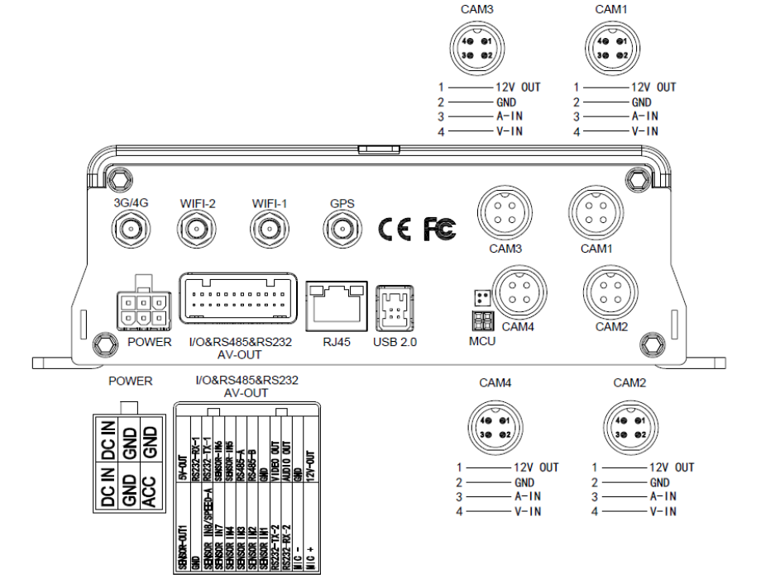

If you are test it in your office, you can use a switching power above DC12V-5A to supply the mainframe. In this case, twist the red and yellow cables as a cable to connect it to the positive terminal, while the black one is connected to the negative terminal separately.

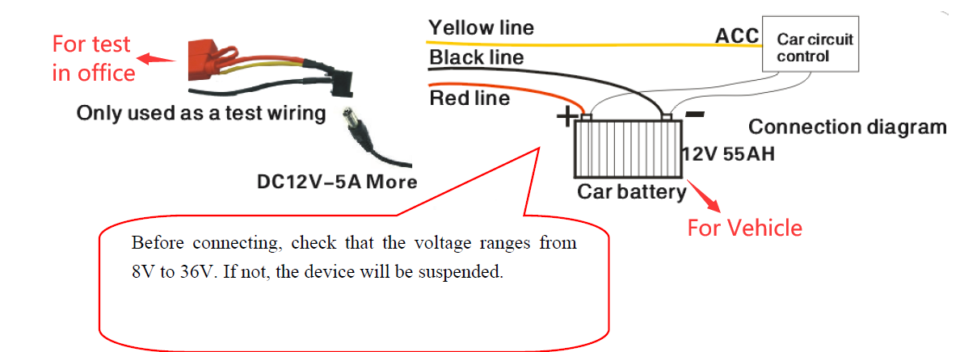

Notice: It is suggested that the vehicle mounted machine be directly powered from positive and negative terminals of the battery cell, or led from the mains power at the fuse without use of ground strap, which may influence normal operation of the mainframe due to negative pulse; The power cable used for positive and negative terminals shall have diameter of φ1.5mm or above.

