How to upgrade the firmware of the BodyCam

- Unzip the upgrade tool

- Open the upgrade tool, and click flash_tool.exe

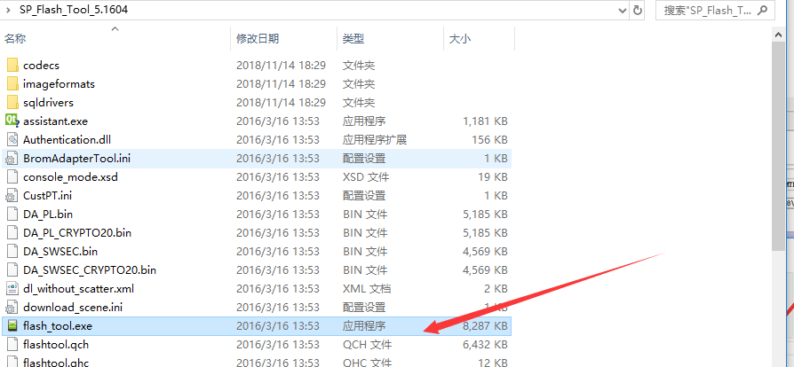

- Selec the download DA file

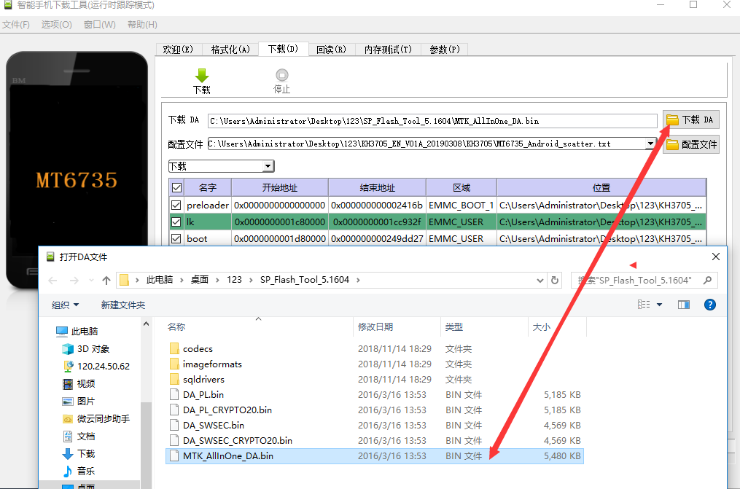

- Unzip the upgrade file

- Select configuration file

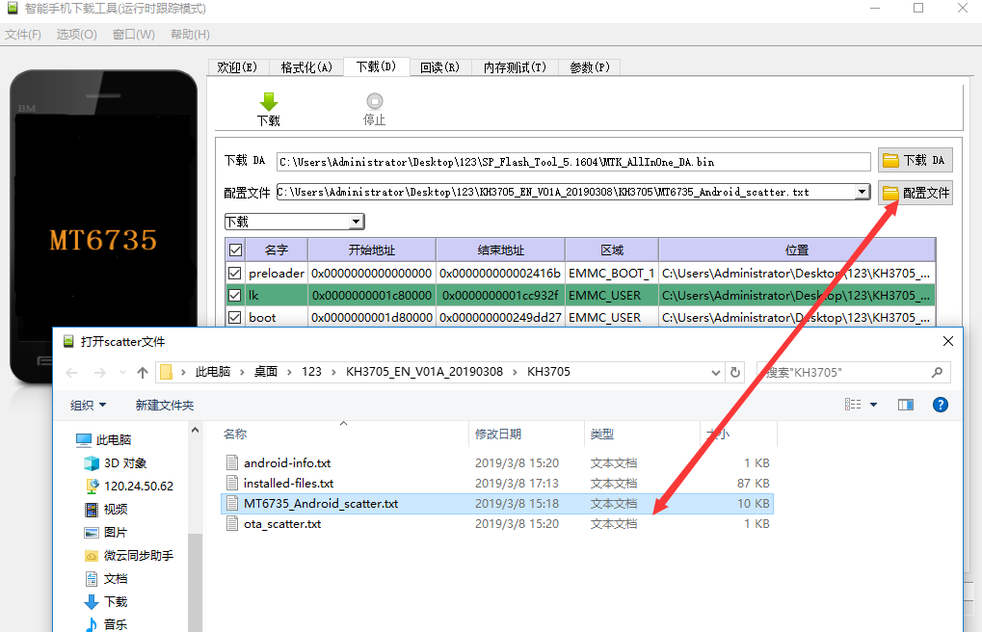

- Select firmware upgrade and then click download button

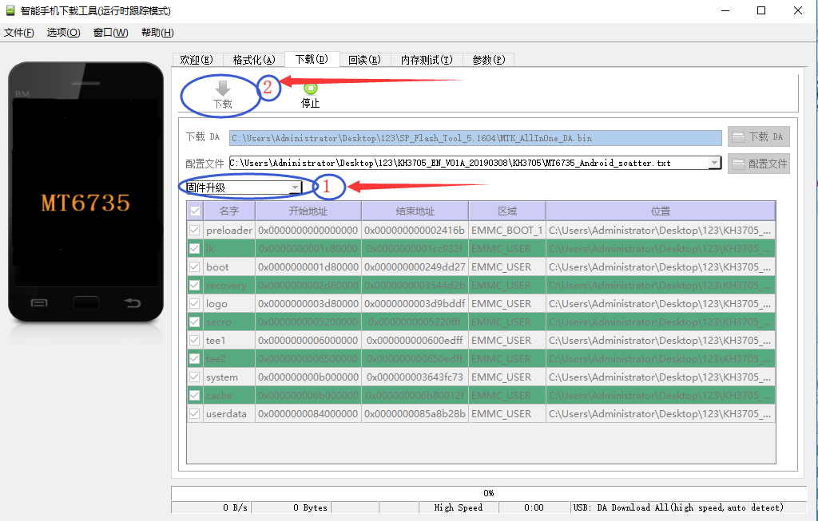

- When upgrading, you need to remove the battery of the law enforcement instrument. Connect one end of the USB cable to the USB port of the law enforcement instrument, the other end to the USB port of the computer, and then insert the battery to automatically connect the upgrade firmware.

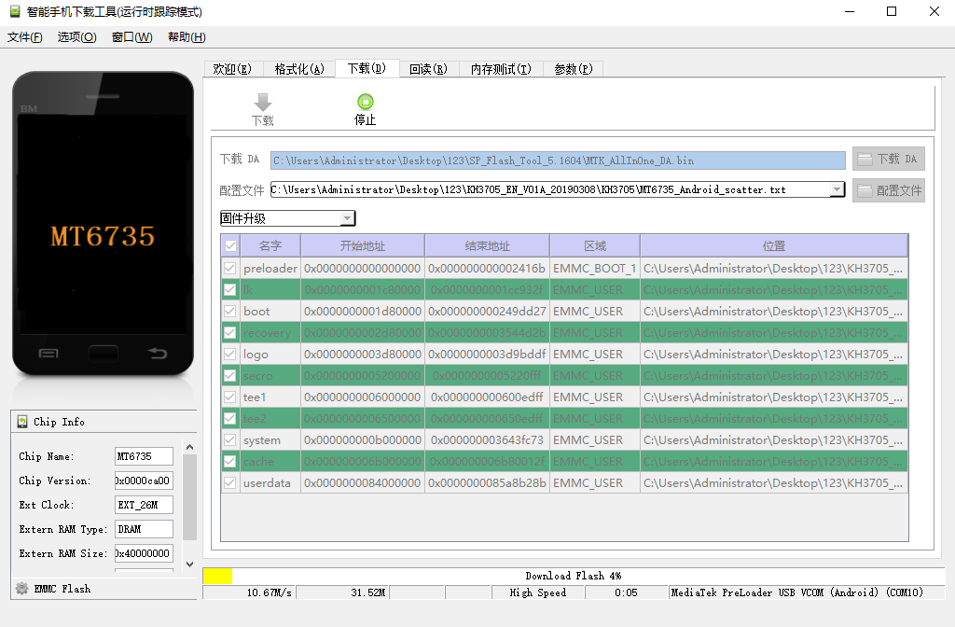

- Connect success and operate upgrade

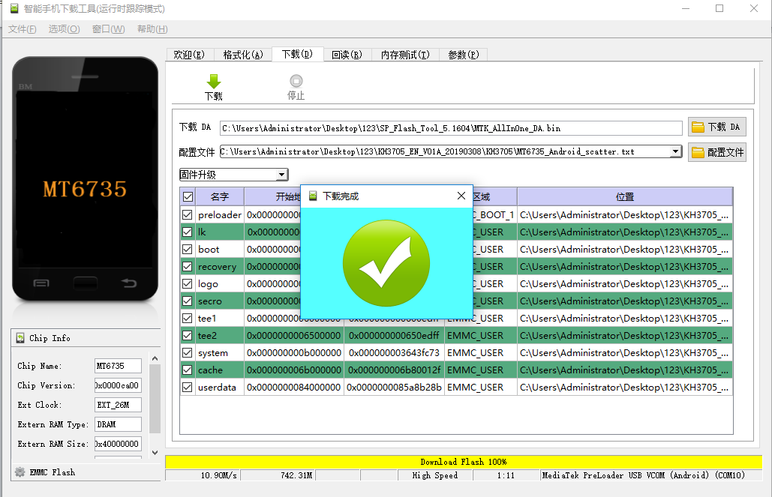

- The download link of the BodyCam firmware upgrad

https://www.dropbox.com/s/89k8p1r98gtxl90/%EF%BC%88The%20upgrade%20tools%EF%BC%8902SP_Flash_Tool_5.1604.rar?dl=0

