How to Migrating GPS data to other path

​1. First, stop the IVMS Server and open the IVMS Server installation directory, find GPSDataSvr.ini, then Open it.

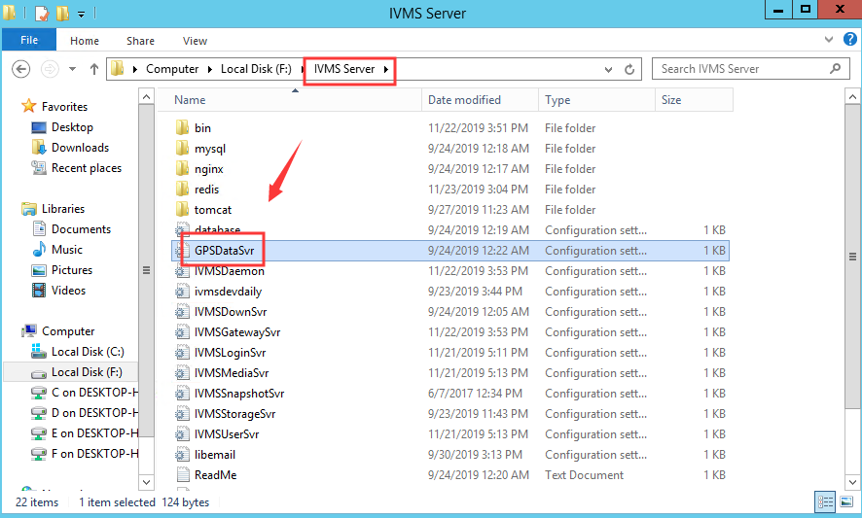

2. Chang the GPS data storage path, and save it.

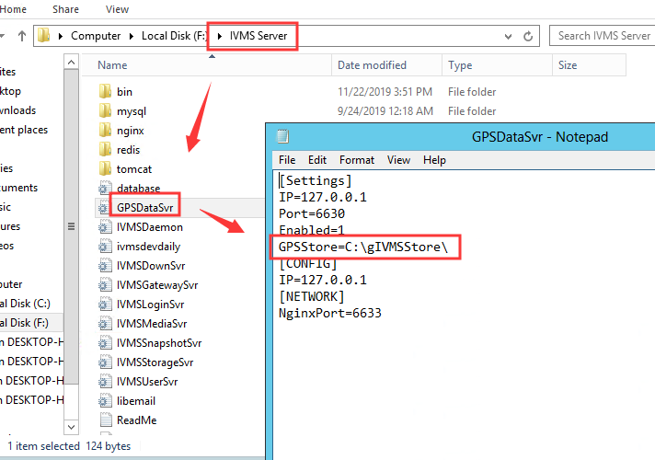

3. Find the GPS data from the old folder, then copy the whole folder to the new path, then restart the IVMS Server.

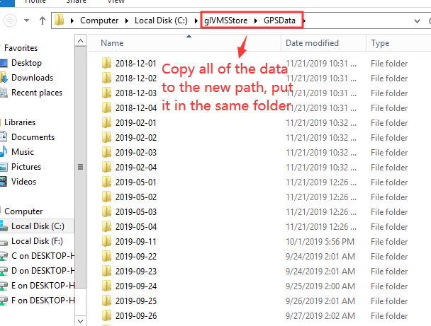

4. When all of the service is running, open the IVMS Client to check if we can find the GPS data from client side.

