Before programming ：
- To install the Command Line Tool “SecureCRT”，to run the SecureCRTPortable.exe：
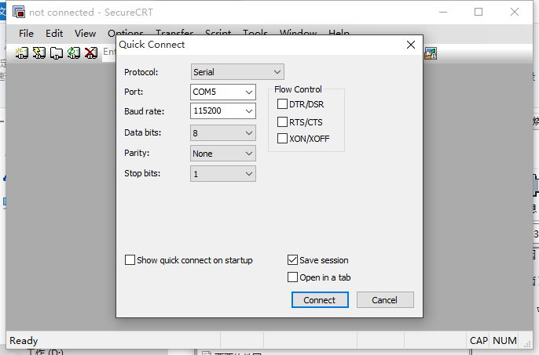

- Port option：[computer management] – [device manager] , you will see the port [COM & LPT]

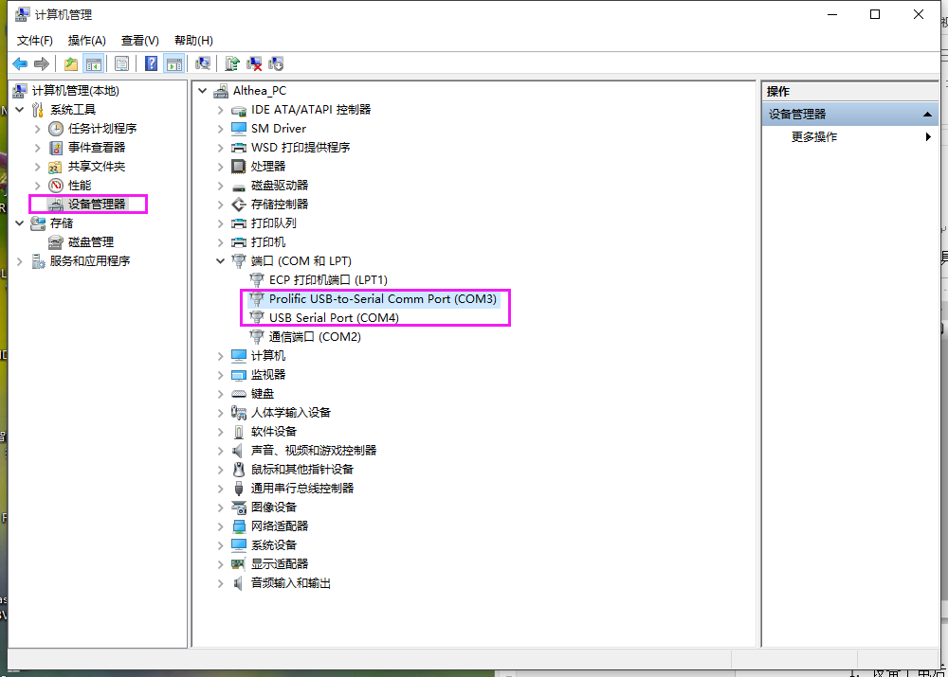

Start to program：
1. to power up the device, to enter “CTRL+C” on serial port page, enter u-boot.
2. to connect the LAN cable to the device, and connect to the LAN ( the device and the programming PC should be in the same local area network)
3. to use remote control composite key to close the watch-dog: 8+F3+F1+Auto //to repeat it 3-4 times，in order to close the watch-dog 4. to set up device network parameter: //normally to set up once
setenv gatewayip 192.168.1.1 //gateway setup
setenv ipaddr 192.168.1.199 // IP address setup, be aware not to conflict with in other IP in the LAN
setenv netmask 255.255.255.0 //mask setup
setenv serverip 192.168.1.186 // to config it as your TFTP server’s IP, normally it should be the IP of your PC.
5. sa //save the config
6. printenv //view the parameter
7. to open tftpd32.exe
To set the home directory of tftp as：X:\tftp（normally it should be the directory where the Flash is）
8. to program with 32M，input the command on the serial port page:
mw.b 0x82000000 ff 0x2000000;tftp 0x82000000 JH4_HYBRID_flash_T16112202.img;

sf probe 0;sf erase 0 0x2000000;sf write 0x82000000 0 0x2000000
input the command according to the prompt：
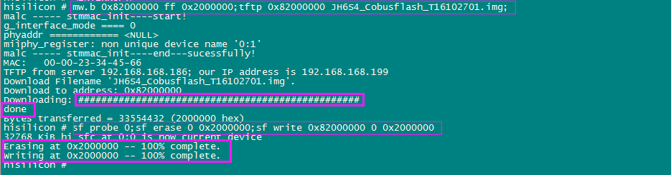
9. reset: after finishing the above steps, input “reset” command, then restart the device.

