Audio pick-up

Audio Pickup in Vehicle
Advantage：
1.high sensitivity;
2.low noise;
3.low distortion;
4.small size
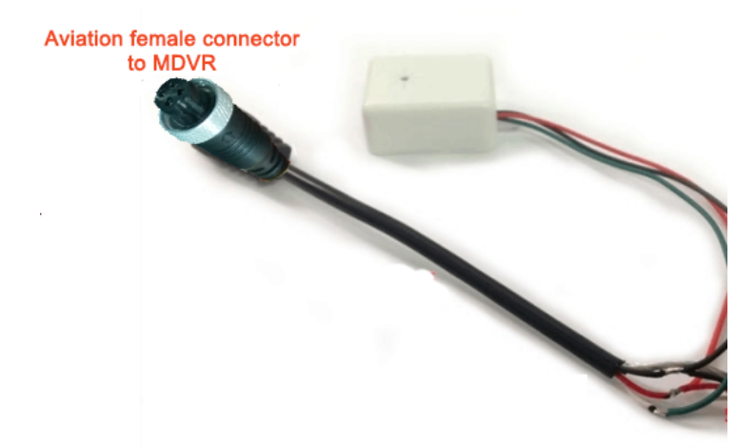
Specifications：

Voltage Input: 9～15 V
Power current: 5 mA～60 mA
Sensitivity: 200mA/ubar
Frequency: 500～10000 HZ
Max output Voltage: 2V-upp

