External Temperature Sensor

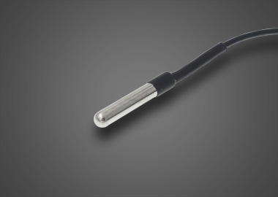

A. Product Features:
- Operating Voltage:3.5V～5V
- Temperature distance:1M～500M
- Operating Temperature Range:-30～+80℃
- Storage conditions:-10℃～+40℃，Relative Humidity≤75% RH
- Test temperature accuracy:Computer software testing, the accuracy of the product in a heated tank of 0.001 °, R25 ° reading error of ± 1 °; using specific errors adjusted according to supply their own customers as well as programs.

B. Product Description
Temperature sensor is to point to to feel the temperature and convert it into a usable output signal of the sensor, products after pulling force, vibration, landing, high and low temperature, resistant to moisture, high and low temperature cold circulation rigorous experimental, with high reliability, long life, by the impact of the working environment and characteristics of. Matched with the vehicle mdvr equipment, in order to achieve high / low temperature alarm, alarm data statistics, reporting, analysis and query.

C. Device installation figure
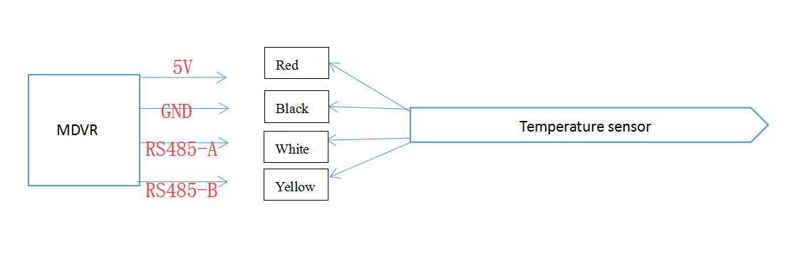

D. To set up the configuration of the MDVR
Firstly, login the device, and set up the MDVR by following steps
- Choose the Alarm to set the temperature Alarm.

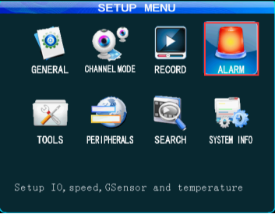
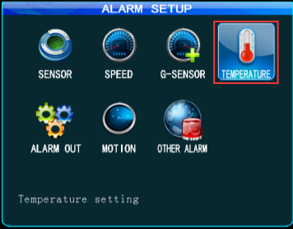
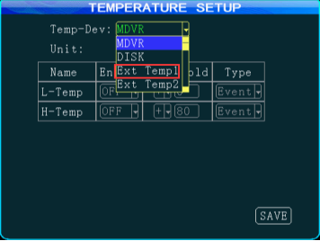

- Choose the Temp sensor in MCU COM1,then save it.

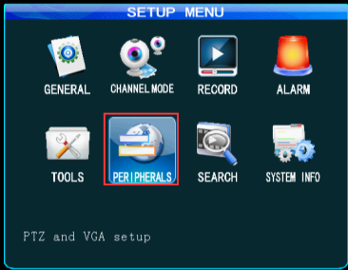
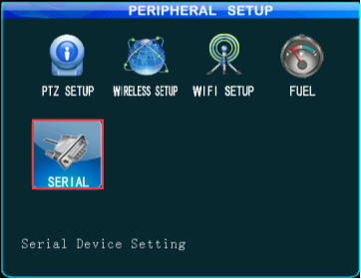
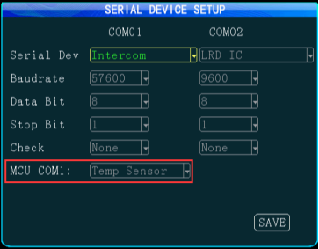

E. To set up the web application
Log into the web application,
At Device-Vehicle Parameter-Edit-Temperature, and select the number and sensor.
The temperature sensor 1 is for the temperature of device, the temperature sensor 2 is used for external temperature sensor 2, and the temperature sensor 3 is used for external temperature sensor 1.

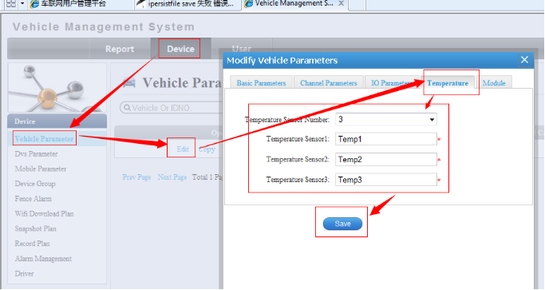

F. Setting Successful
User can check the temperature value of temperature sensor (temperature sensor 3) at Status from Client. Also you can see the temperature in MDVR(System info).

