# Geo Fence Config

1. Log in to the IVMS client and select Geo fence shapeIt will pop up a window and please add the name of the fence, click OK.

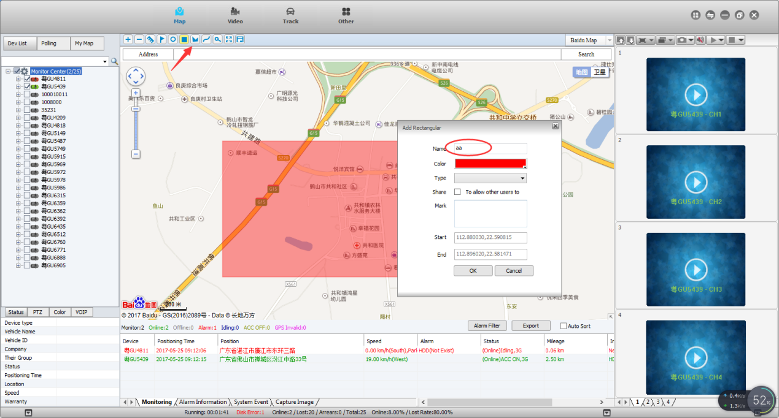

2. Select the Terminal parameters and fill in the basic settings in the window shown as below.

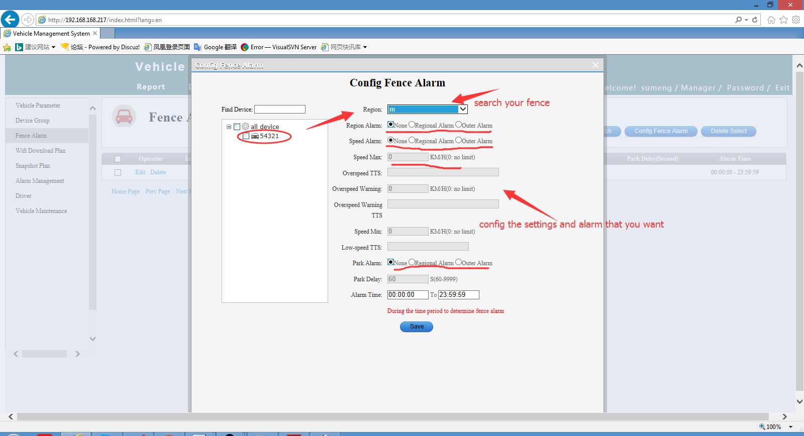

3. Select the Geo Fencing report

