How to Make Web Download by Using Firefox

1. Use the link do download the former(old) version of Firefox explore. Select the win64/ if you are using win7 64-bit. And then select the language you need.
http://ftp.mozilla.org/pub/firefox/releases/54.0.1/

2.Then select the version as shown below and download it.

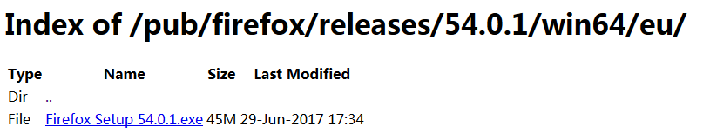

3. Install the Firefox, and open the Firefox explore. Click the menu at the top right corner. Choose the option which marked in red line. When enter into it, there are some options at left, please choose advanced to stop the update function.

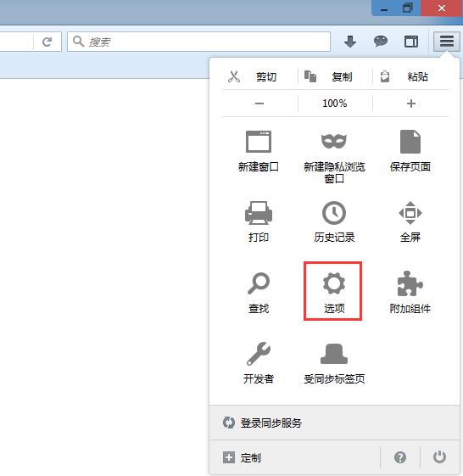

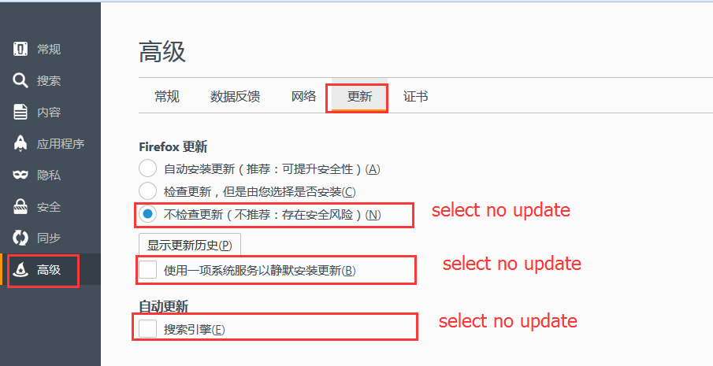

4. Input the IP address in the search bar as shown below. Then go to the Video search and click the drop list.

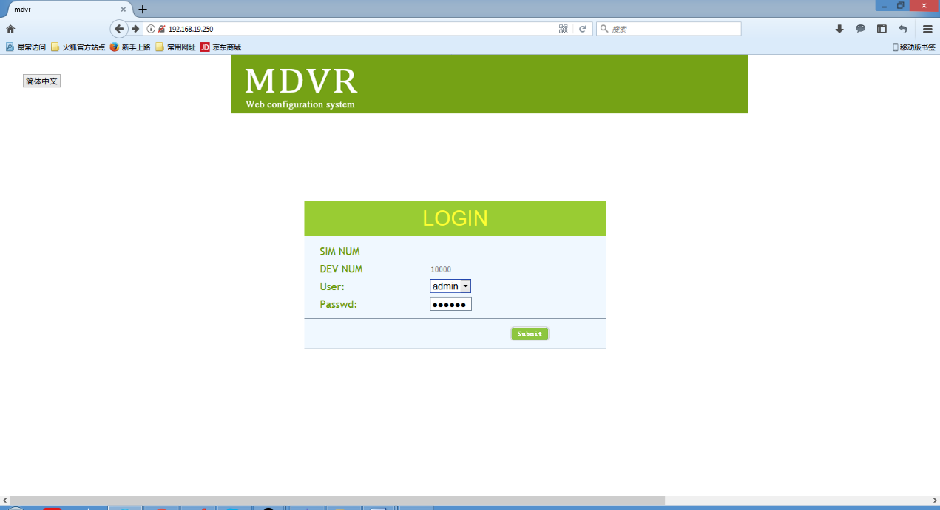

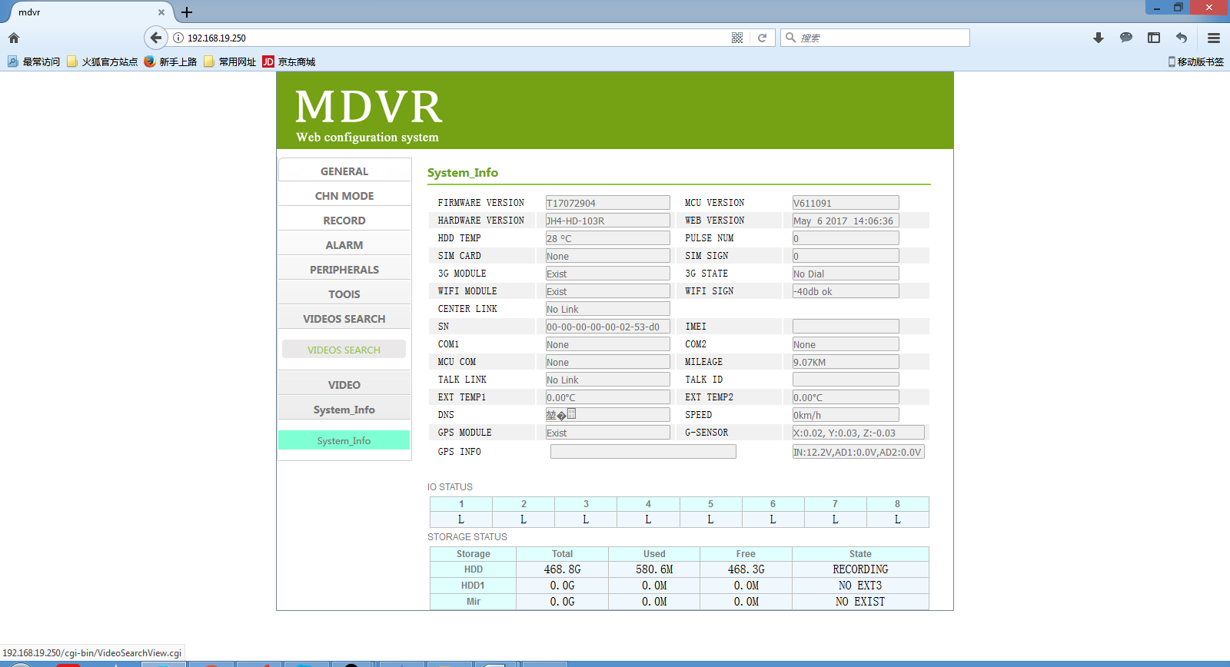

5. When enter into the search interface, select the path, date, type, channel. Then you will see the video search result list. At last, at the blank area, right click and select DownThemAll to download the file. The download links will generate and you can select which one you want to cancel or select to download, and the path you want to save.


