How to remove the enclosure of the MDVR
When the MDVR get some error , customer always want to remove the enclosure of the MDVR, then check the prolem, but some of them do not know how to remove this, so you can check it as below.
1. For JH6S device, you can remove the screws like this:
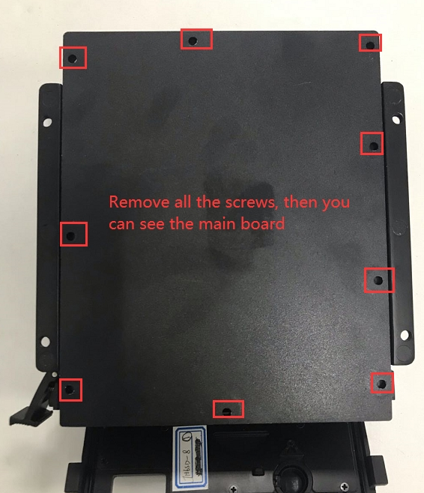
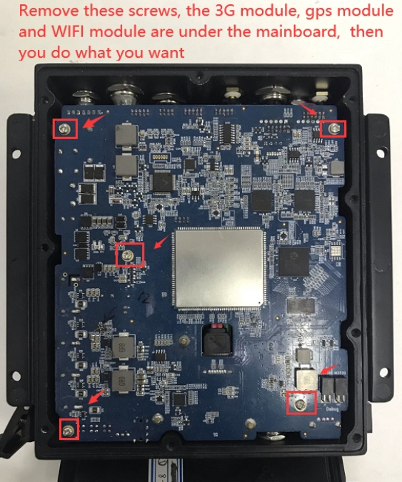

2. For JH0-HD, you can remove the screws like this:
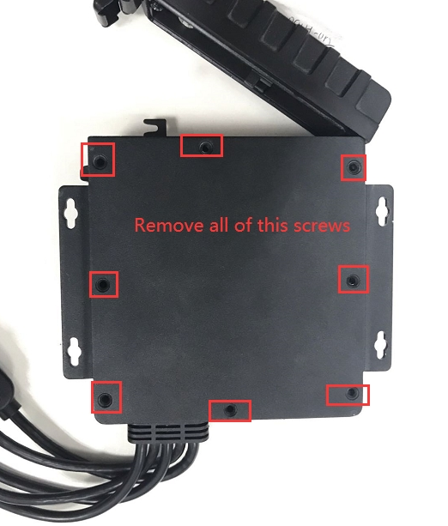
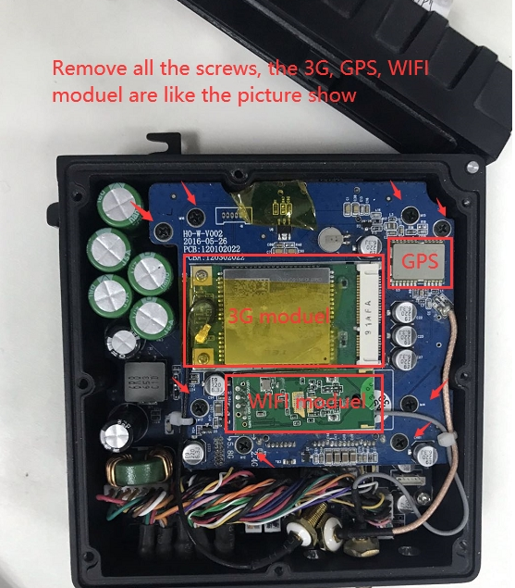
3. For JS2-HD, you can use the hex key(you can find it at the attachment box) remove the screws like this:
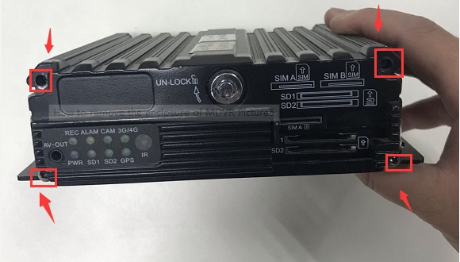
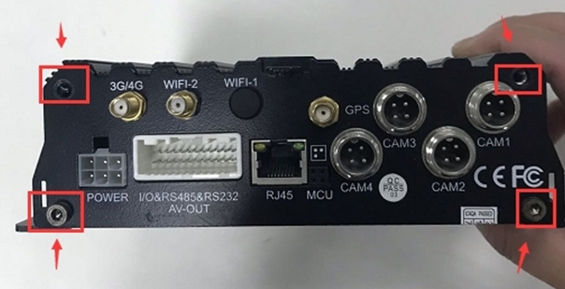
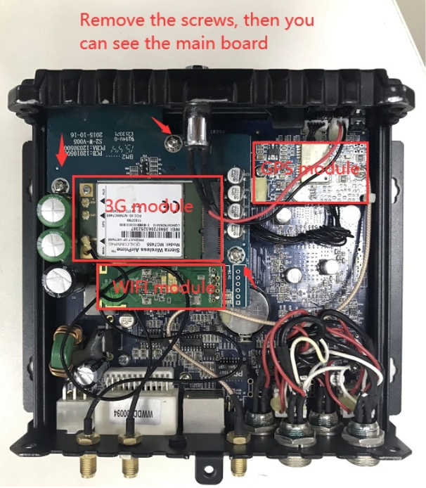

4. For JH4-HD/JH8-HD/JH4-HYBRID/JH8-HYBRID, you can check it from this link:
https://www.icarvisions.com/faq/how-to-replace-the-4g-module-on-the-mdvr-486.html

