How to change the AI-BOX-A alarm speed via Android APK

1. First you need to make sure your AI-BOX version can support this, if your version can not support this, you need to upgarde it first, you can upgrade the AI-BOX version like this, you can check it from this link:
https://www.icarvisions.com/faq/how-to-use-usb-serial-port-to-upgrade-ai-box-a-503.html
2. After upgrade the AI-BOX version, we need to upgrade the Android version, you just need to put the adasDsm_2020031005_71.apk at the SD card(Fat32 format) root directory, and connect it to the AI-BOX's SD card slot, then power on the AI-BOX, it will upgrade itself. (You can get this APK version from our Technical support engineer side)
3. Install the new APK version to your phone, then use your account and password login, the APK version is like this picture.
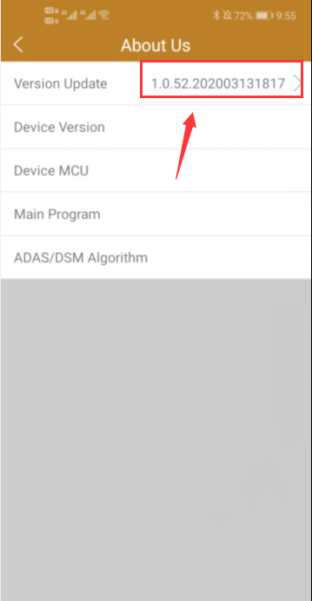
4. Let the AI-BOX enter the test mode, then use your phone connect the AI-BOX WIFI, you can calibrate ADAS and DSM first, and you can set the Alarm speed at this side, then you can check if it is working at your side.
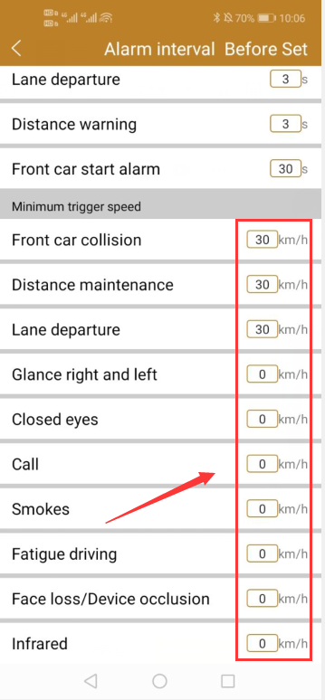
Notice: Only DSM alarm support 0 km/s, ADAS alarm still need more than 30km/s.

