How to upgrade firmware of Dash IP Cam
- Prepare the tool for the upgrading, need SD card, the format is Fat32, the Dash IP Cam and the power cable.
- Switch the power of the Dash IP Cam, make sure before upgrading, the Dash IP Cam is power off.
- Decompress the .rar file, copy the .crc file to a SD card, and insert the SD card to the SD card slot 1, next to the sim card slot.
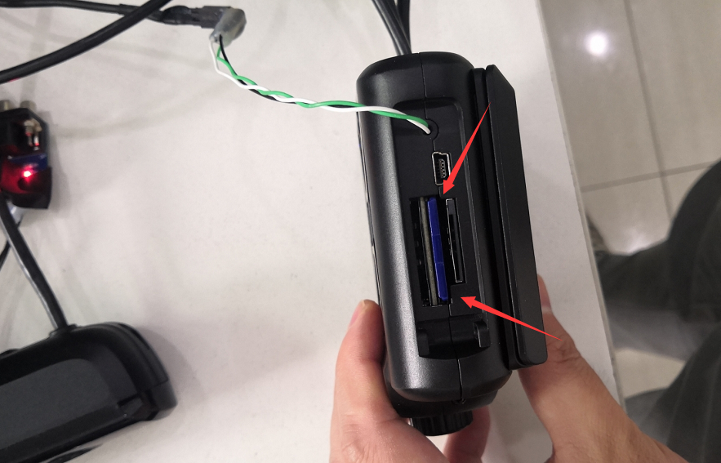
- Power on the Dash IP Cam , it will update automatically, and please wait 15 minutes for the process. As for now the upgrading can not be viewed.
- After upgrading, please login the account of the Dash IP Cam, and check the version information.You can refer to this following linkage for this login operation.
https://www.icarvisions.com/faq/how-to-config-ji2-ji3-via-android-phone-448.html
