When you query the GPS address to load the map from the web, when you close the map, it will show Chinese term “关闭”, the following is to show how to fix it.
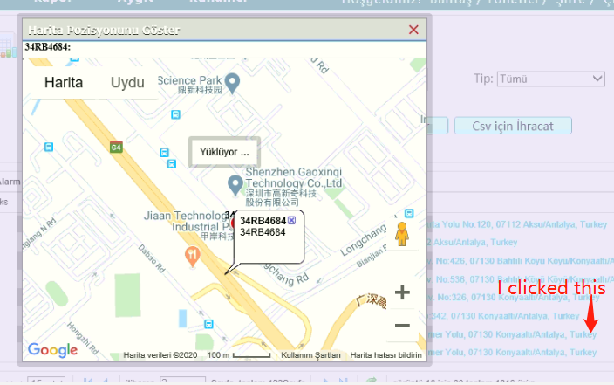
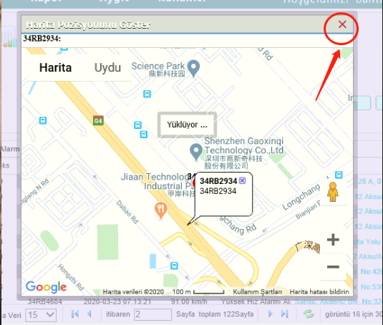
- First, find the path of the following. It’s because the windows program with codec for Chinese term, so need change the code from .js file.
- After find the path, find the next command line.
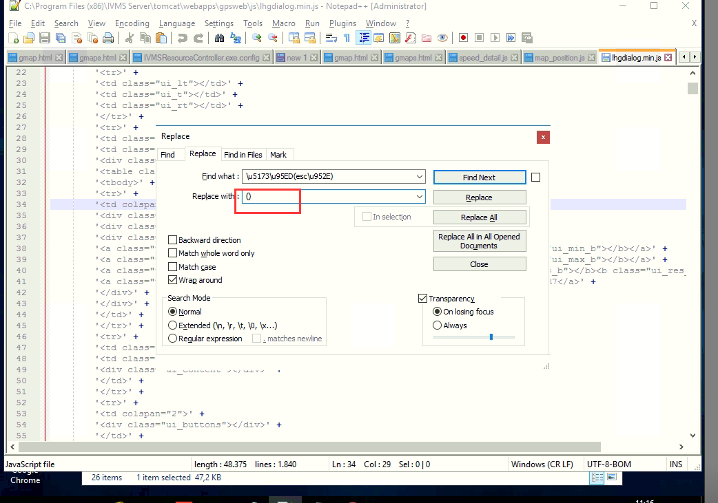
- Find\u5173\u95ED(esc\u952E), and then replace it with the words you need, at this place you can input ESC for exit.
- After change, save the change, and then clear the cache of the explore you are using, and then repeat the operation, you will find that it has been replaced by ESC.

