How to identify the H265 video's start time and end time

When customer use JI2 JI3, new JH0 and JH16, the video record file will be .dat format, and we can not see the video start time and end time, this will be very difficult for customer to check the video via package time.
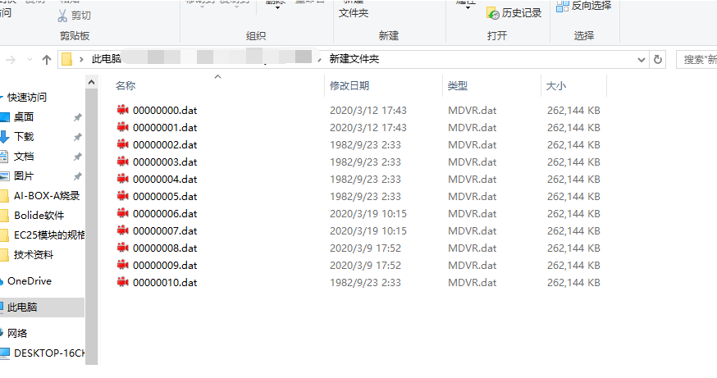
1. First, install the newest MDVR Player, you can download it from this link:
https://www.dropbox.com/s/w9lp6fllz7rby80/MDVRPlayer_WIN_8.20.03.17_STD.exe?dl=0
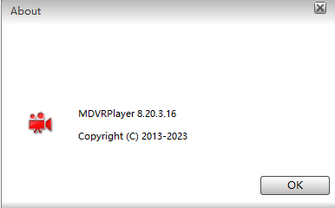

2. Choose the .dat file folder, then it will show the file list at this side, and you can see the video start time and end time.
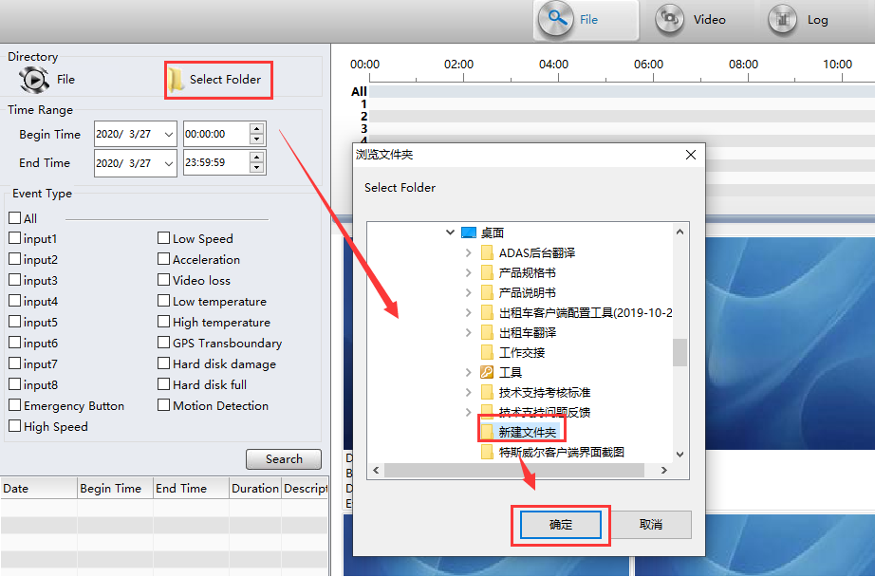
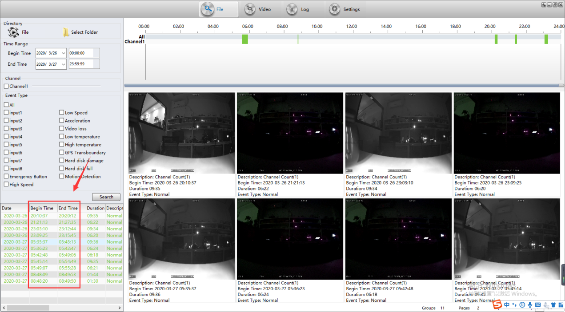
3. Choose one file and right click it ,you will see the selete file option, click it, it will jump to the folder and select the corresponding dat file, then we can clear know the the dat file name.
