How to check the CPU temperature of JT1
First. Please prepare the double USB cable.
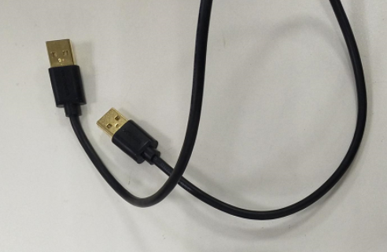
Second. Connect the JT1 and PC with the USB cable as below.

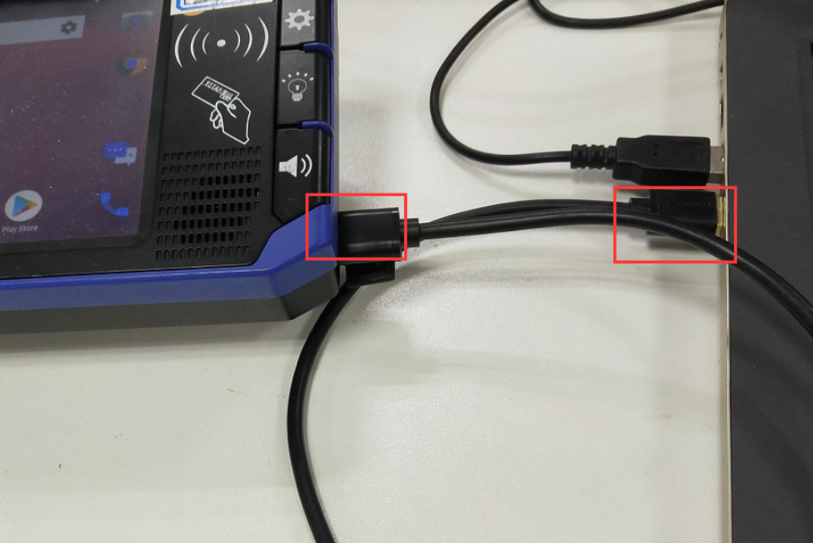
Third. Login the SystemAPI and Click the “Set Switch ADB”
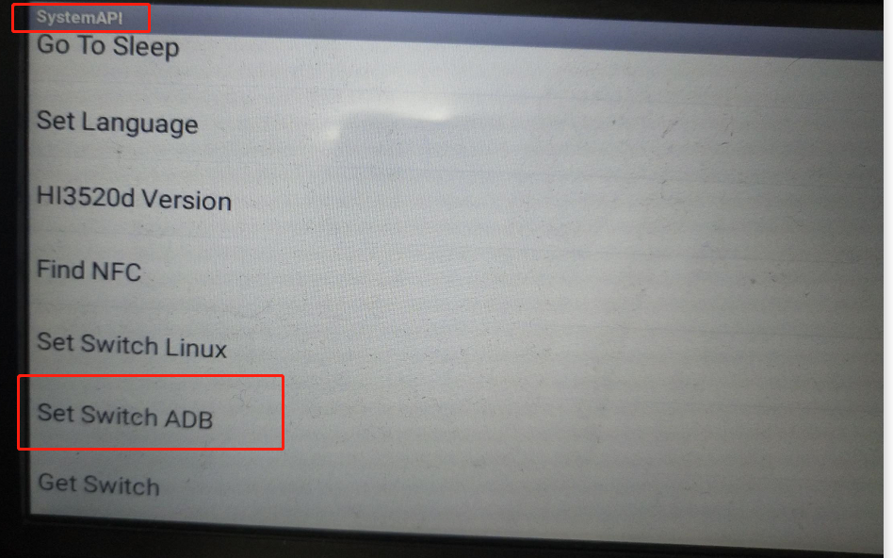
Then you could see the COM 9091 port.
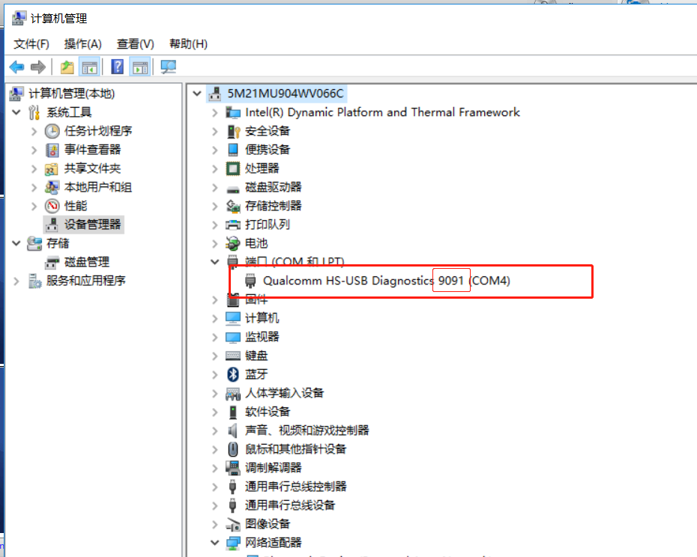

Kindly use CMD and type the follow demands.

adb shell cat sys/devices/virtual/thermal/thermal_zone10/temp

adb shell cat sys/devices/virtual/thermal/thermal_zone6/temp

(Note: The zone 10 and zone 6 are two different position of CPU)

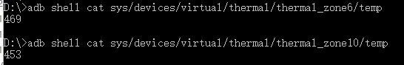
The Temperature result is using the number Divide by 10 such as

Temperature1 = 469 /10= 46.9 °C

Temperature2 = 453 /10= 45.3 °C

