How to connect TV with AV-output
Sometimes, customer need connect MDVR to TV, need use big screen to do operations and monitor the vehicles.So it need follow the step and use cables to make connection.
- Connect from the front 3.5mm jack AV out.
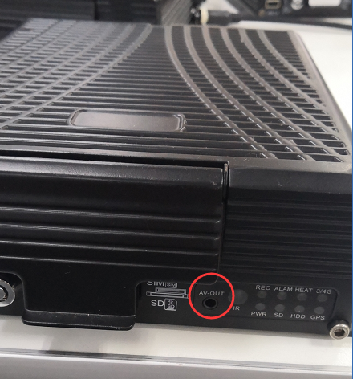

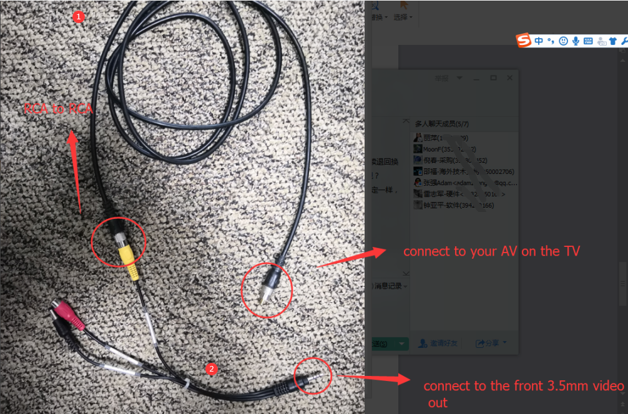
- Connect the convert cable to the AV port of TV.
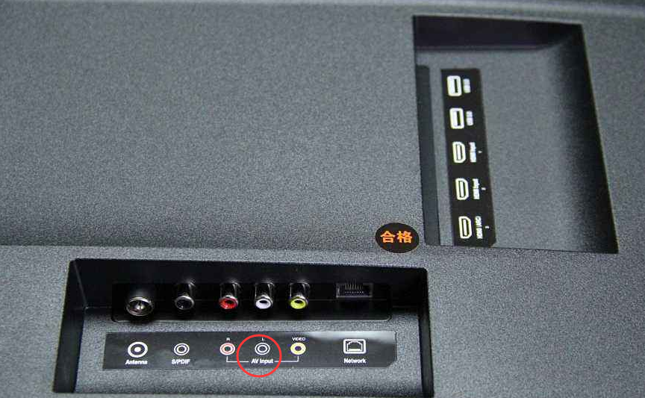
- You can also use the rear port to connect TV. Use the convert cable to connect the  cable in the first picture.
