How to solve the issue about reording but no video file

​How to solve the issue about reording but no video file.

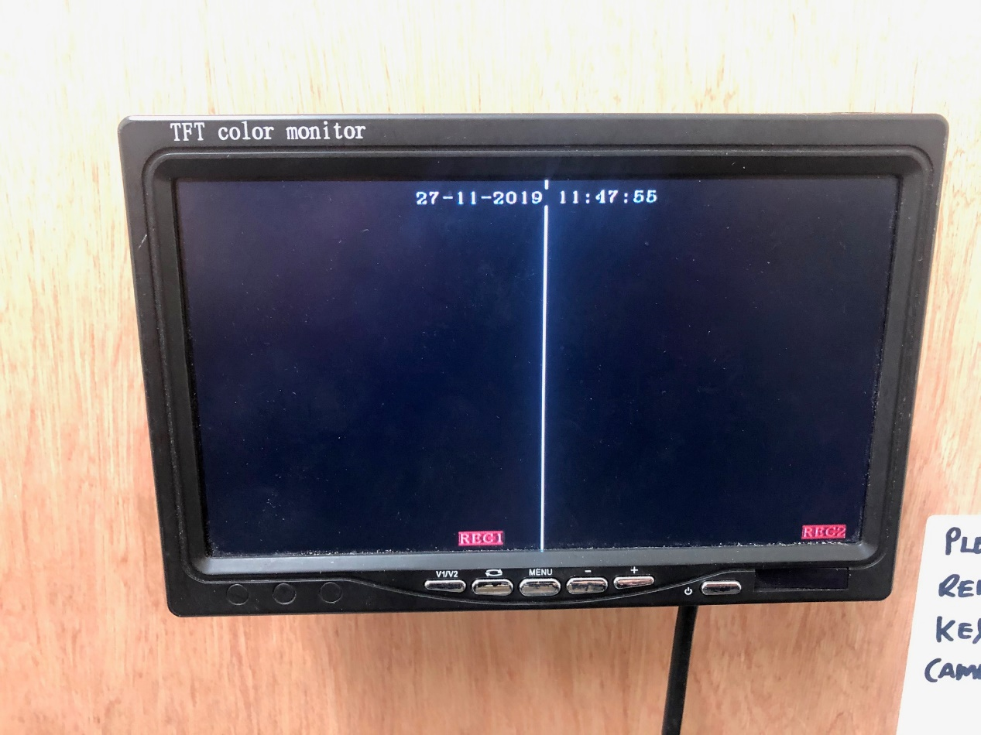

Which type Cameras have the issue? AHD or IP Camera?
If you connect IP camera, plaese share the parameters of the camera to us. Our MDVR can not support H.265 yet. You can select the H.264 via web.

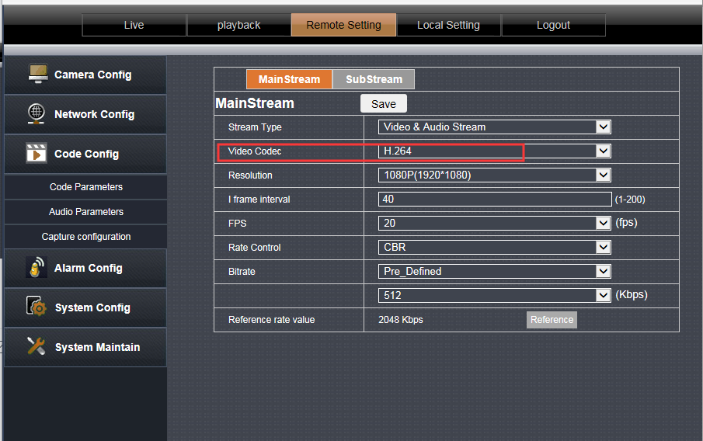

If you connect AHD. There is the ways to check the issue:
1. Please select correct channel mooe of the MDVR, camera resolution and system (PAL / NTSC);
2. SSD format should be exfat or fat32, you can format the SSD by MDVR for a try;
3. Try to recorde via SD.
4. Upgrade the firmware.

