How to solve the IVMS Client uninstall failed problem

When we use IVMSClient_WIN_8.18.8.21_20180821-STD.exe, there is an error that effects some users when a previous version of IVMS client software is updated to a later version. The below step by step guide has been tested to completely remove the corrupted installation file, to allow for later versions of IVMS to be installed.
1. Close the IVMS Client ,also close the service, open Task Manager to Close any IVMS Client.exe files running.

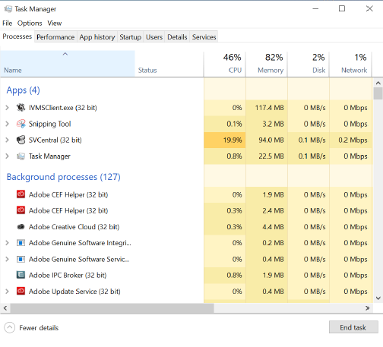

2. Uninstall Intelligent Vehicle Monitoring System - Open IVMS File location, search for the file "unis000.exe", right click and select "Run as Administrator", or uninstall it in control panel, then you will get an error like this, this will let you can not install the new version.

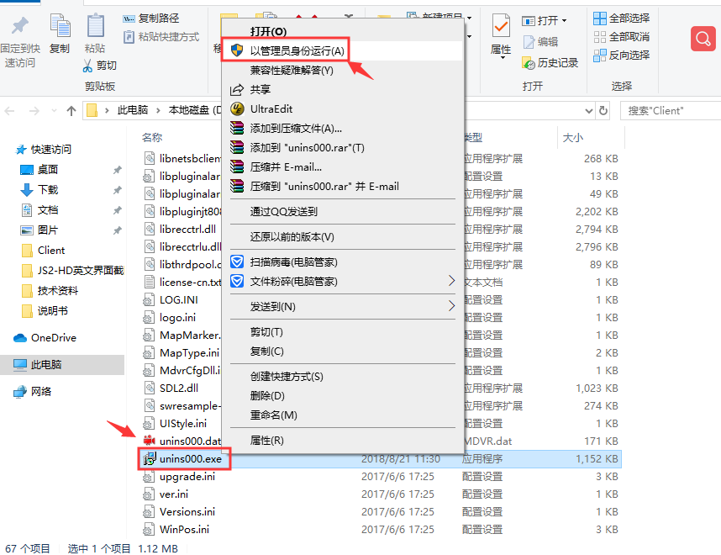

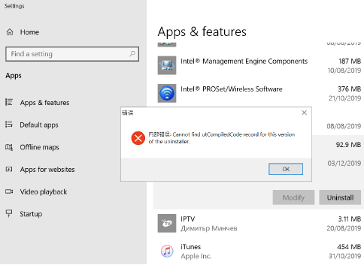

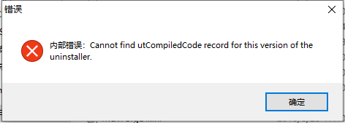

3. For solved this problem, we need to delete all the file under the installation directory, then uninsatll it in control panel again, choose yes to clear all the date, then you can install the new version now.

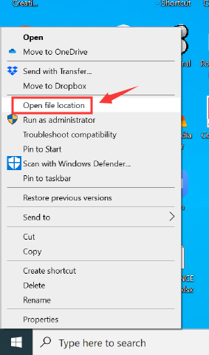

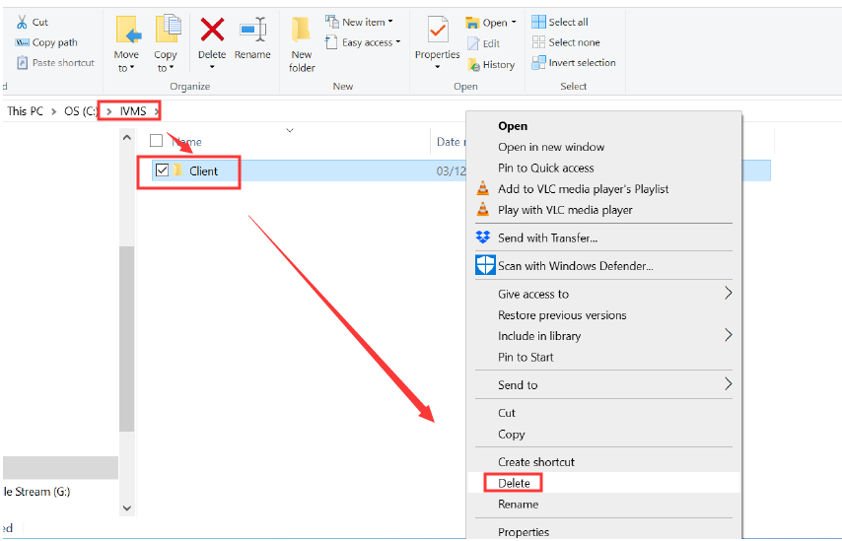

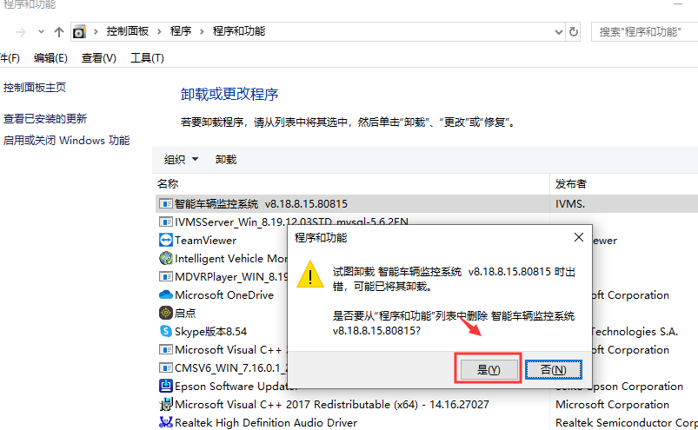

4. Install New Version of IVMS Client – The old version of client software should now be fully removed. Locate the required updated version of software, right click and select "Run as Administrator". The software should now install without any issues.

